# VPC Peering

* A VPC peering connection is a networking connection between two VPCs that enables you to route traffic between them using private IP address
* Here creating two vpc network in same region with subnets

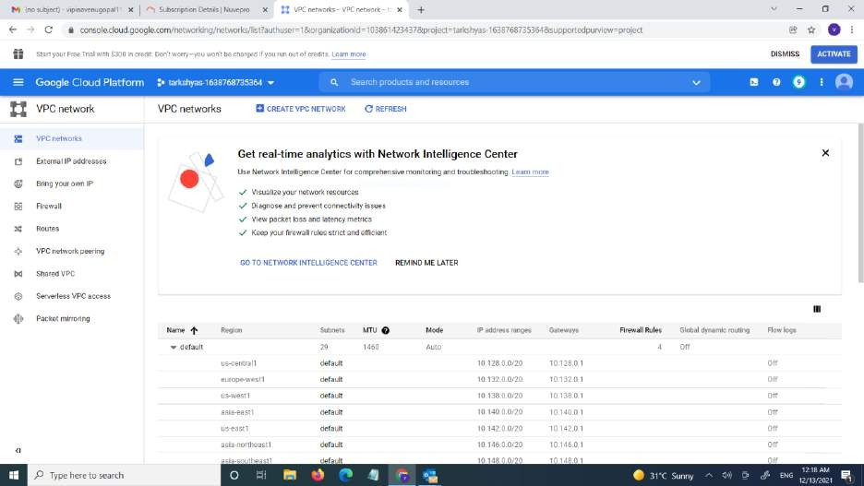

* First created a vpc network called vpc1.And also created a subnet for it.
* Give the region and IP range for the vpc network.
* Then create the vpc1.

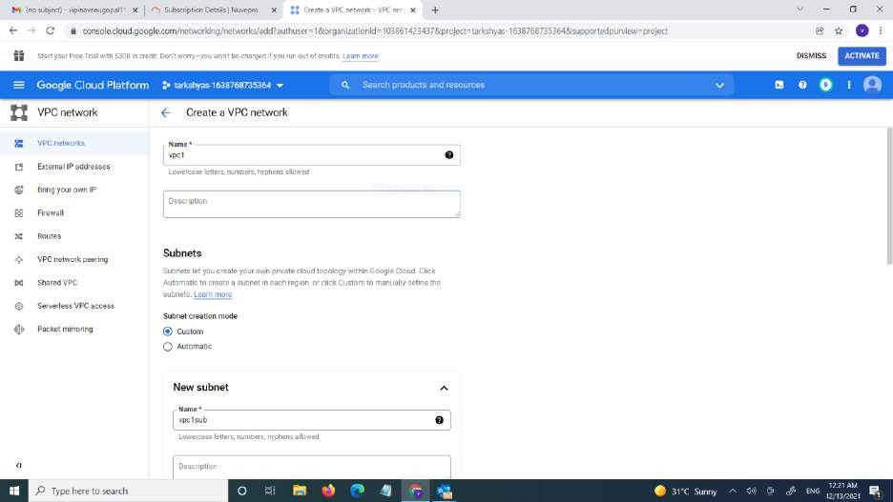

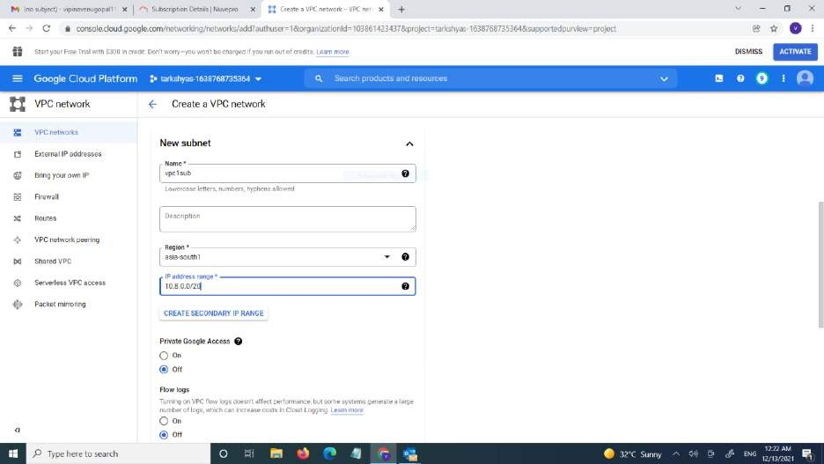

* + Here the vpc1 network is created

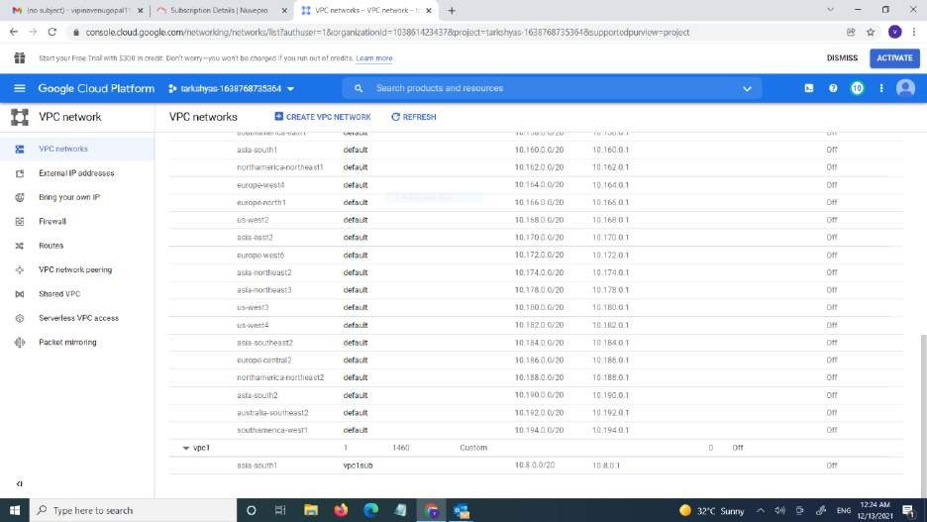

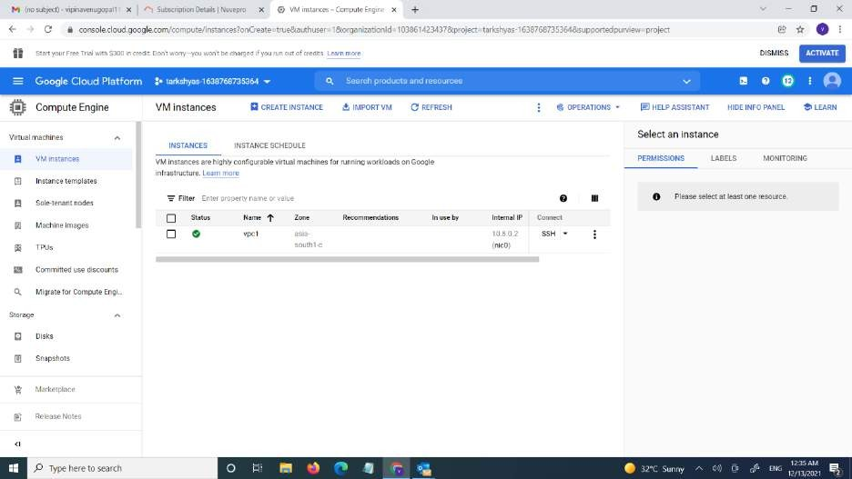

* + created a vm instance with tha vpc network vpc1
  + Then creting the ather vpc network vpc2

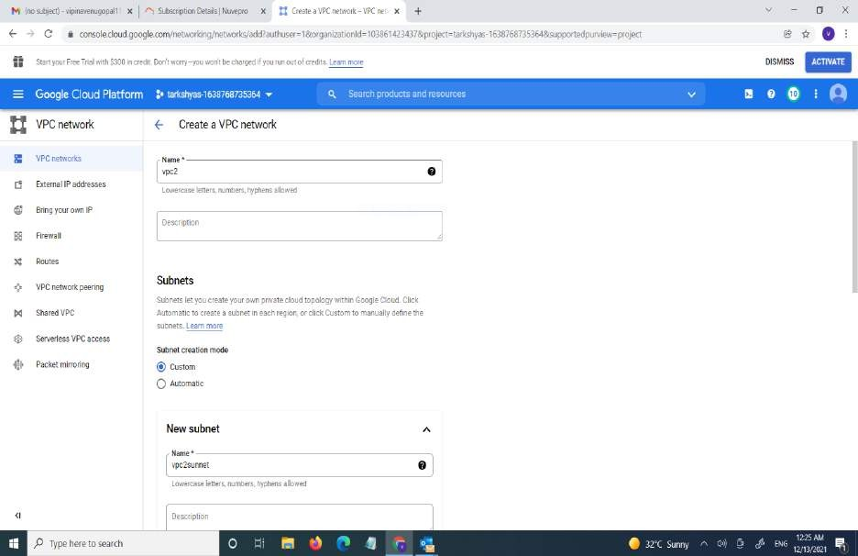

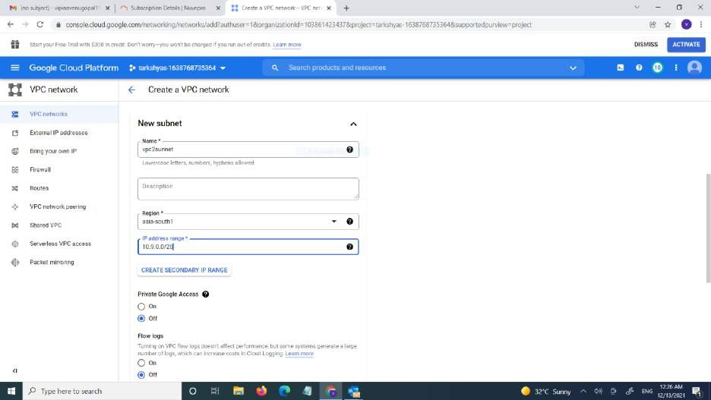

* The 2 vpc networks are created.

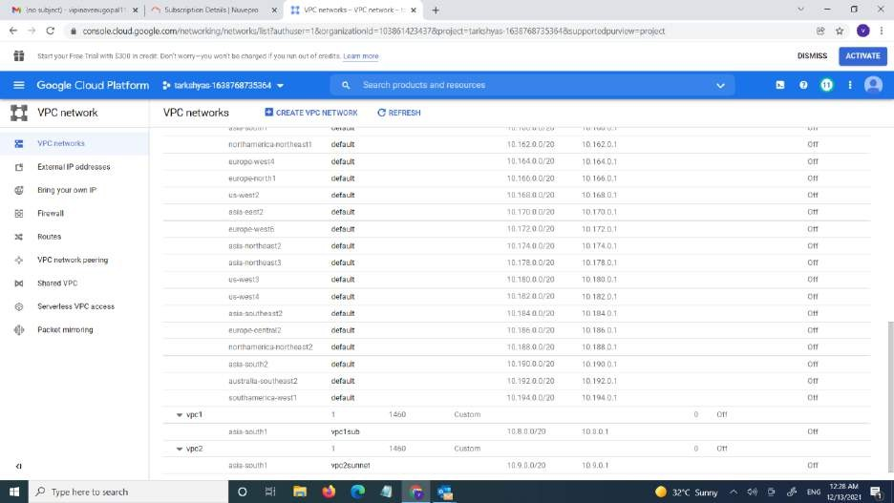

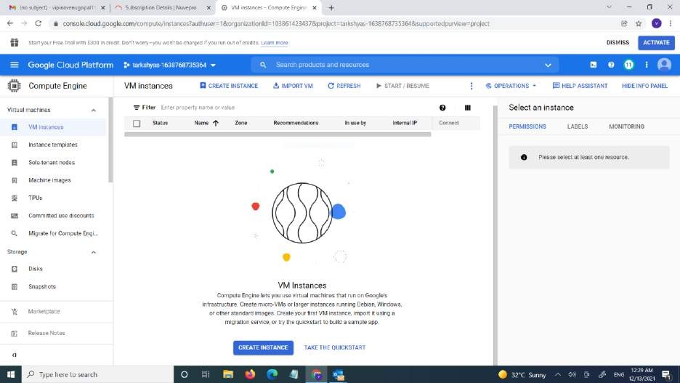

* Next is creating the vm instances.



+ Gréate en instance

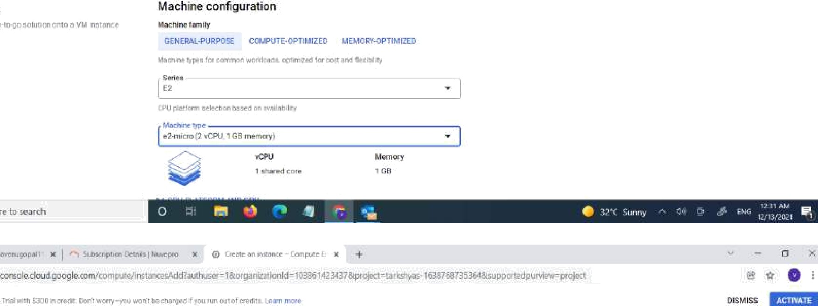



+ Gréate en instance

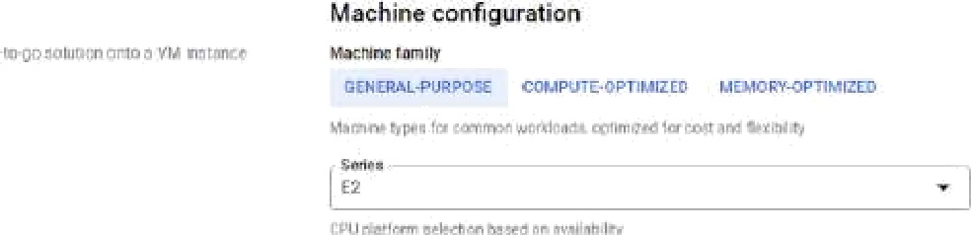



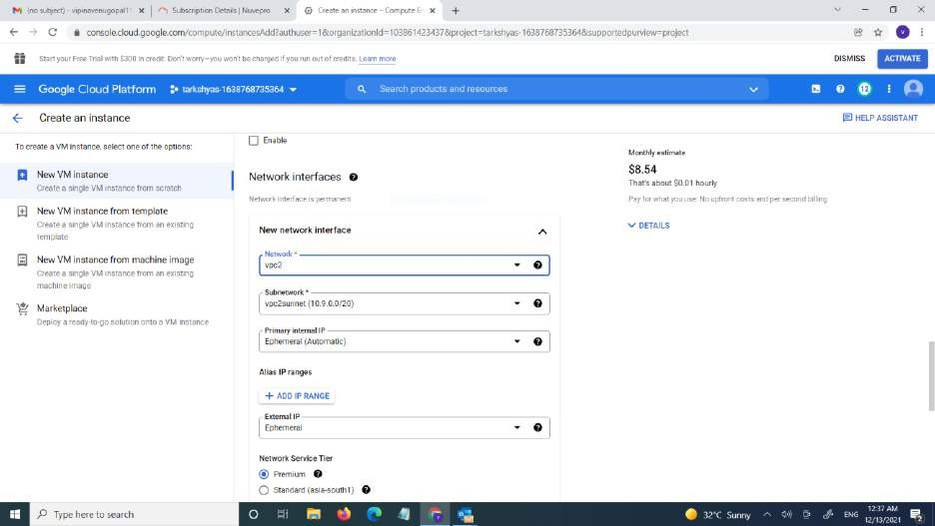

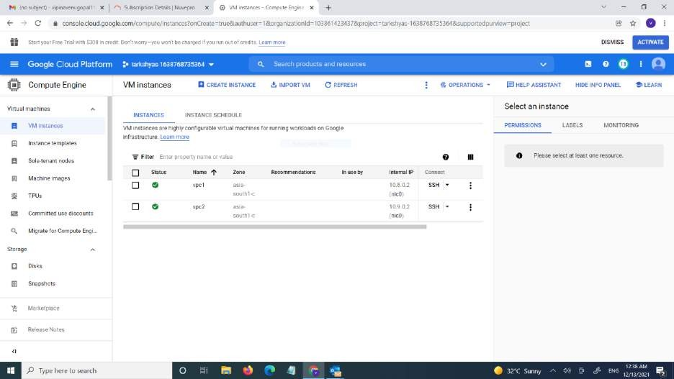

* The 2 vm instances are created.
* For the connection of ssh we want create firewall rule.

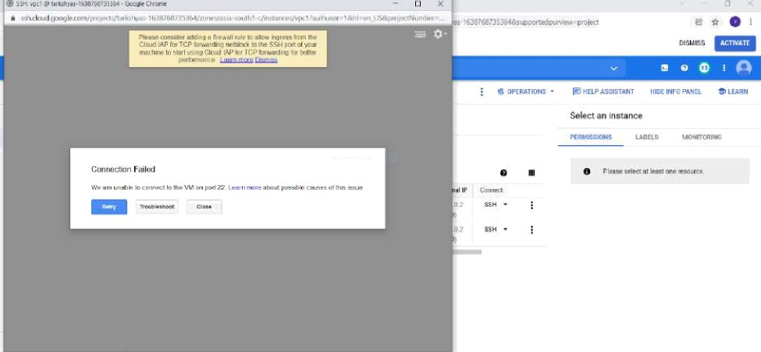

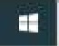





€- VPG network details

a' ¥rr p imcrz we «emo

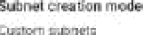









 Create a firewall rule



Create a firewall rule



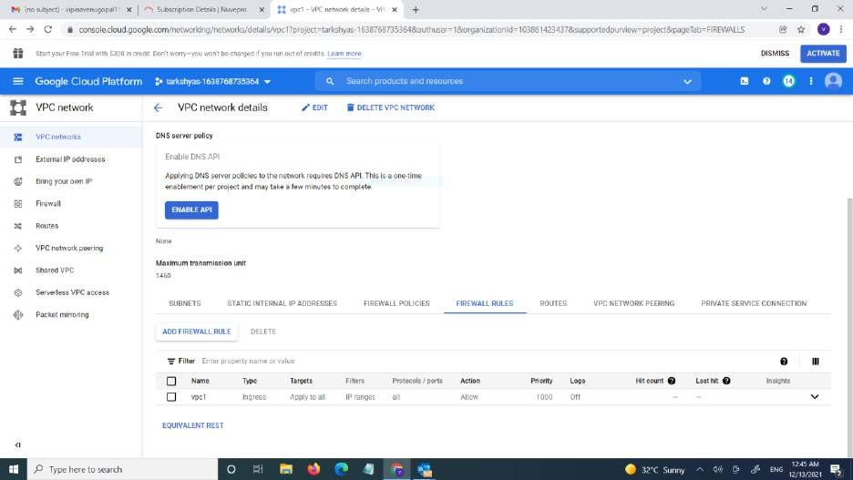

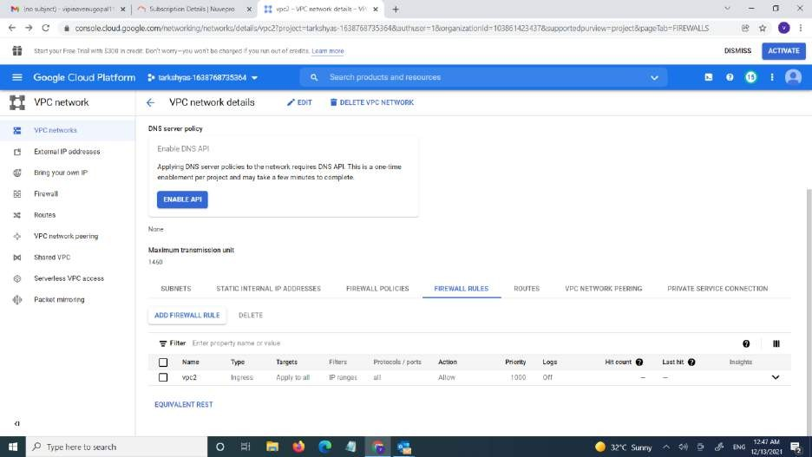

* The firewall rules are created
* For the connection between the two VM instance we want to make VPC pearing netwok

.

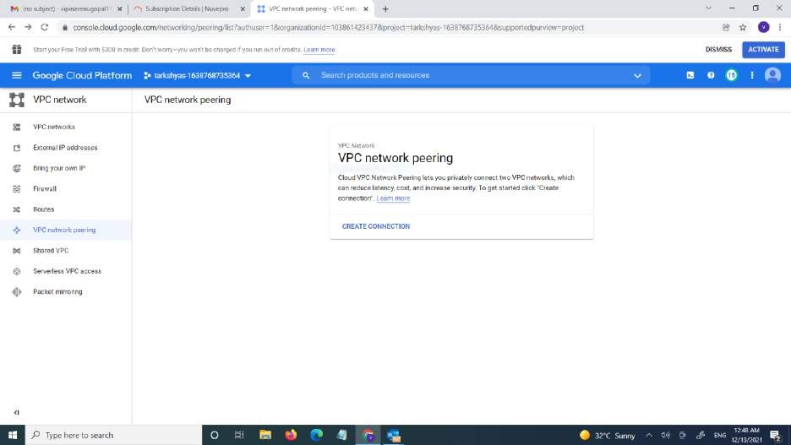

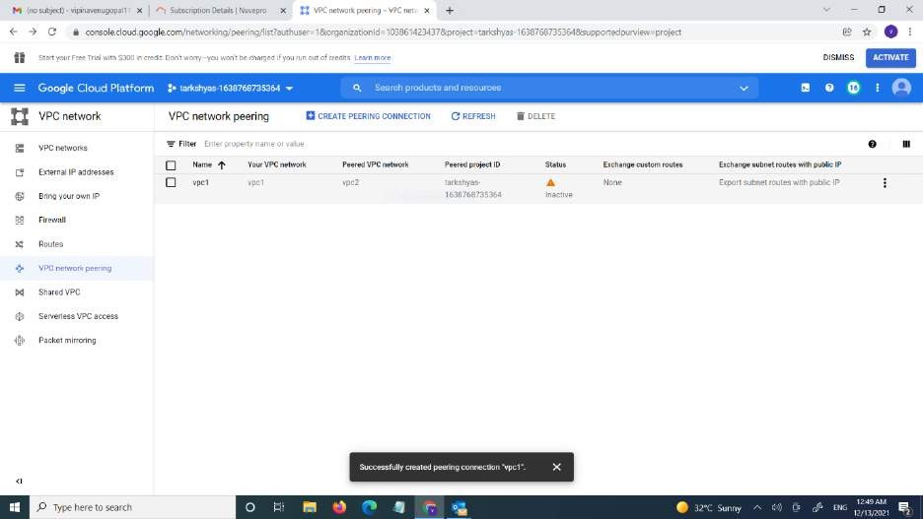

* VPC peering networks are created

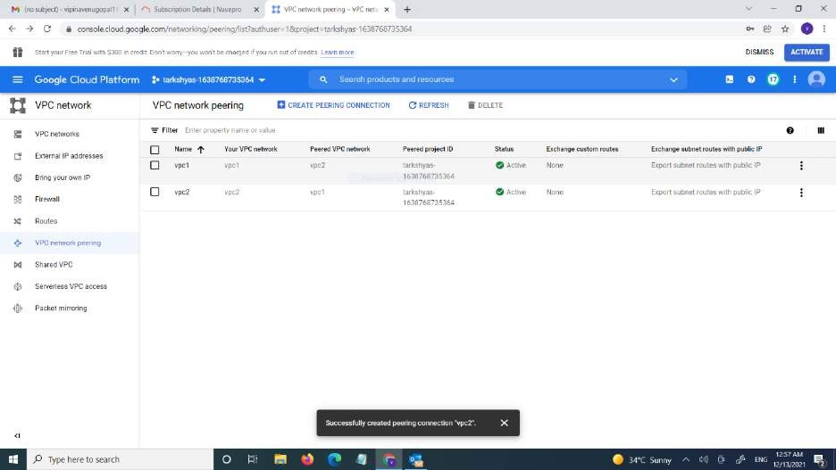

* Now we can see the connection are made

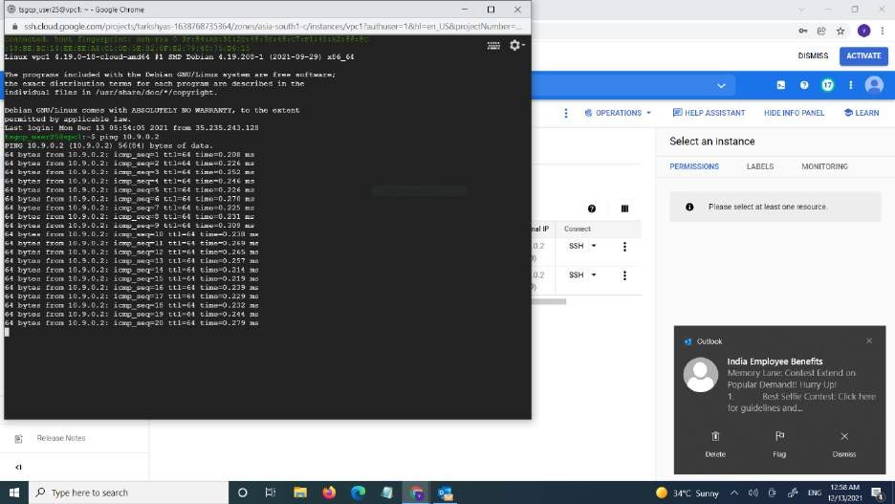

# GKE

* GKE is a managed ,production-ready environment for running containerized application
* First we want to create a directry called demo
* Then add a web site in the git clone to the demo

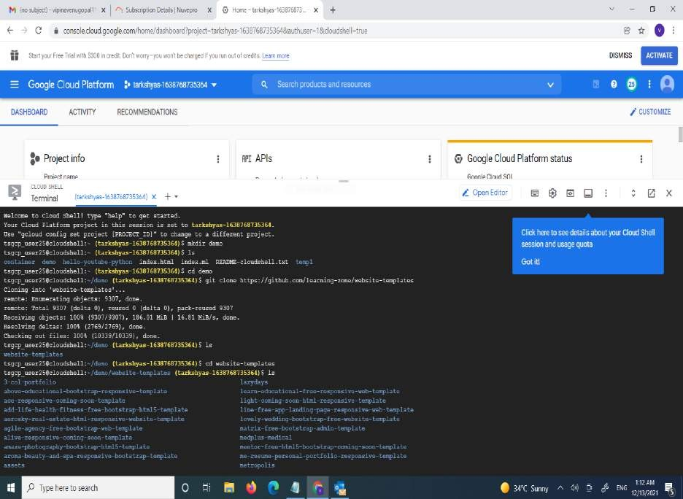

* docker run -d -p 8080:80 nginx:latest:-in cloud run the server is also installed.so we want to simply run the server.-p is we exposing our port which is going to be the local port of cloud shell wich is 8080 .nginx web server is runs on port 80.
* Then we run the command docker is going to pull the latest images.
* Once it download that it runs that container
* Container is a runnable image

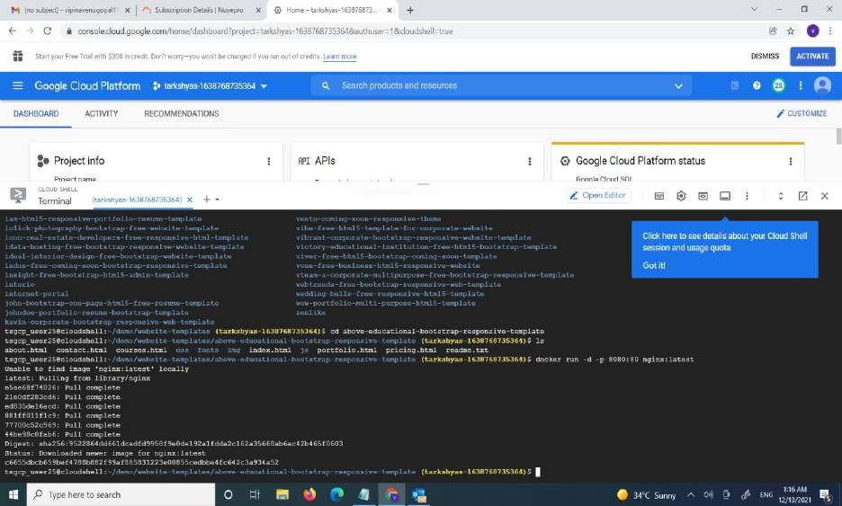

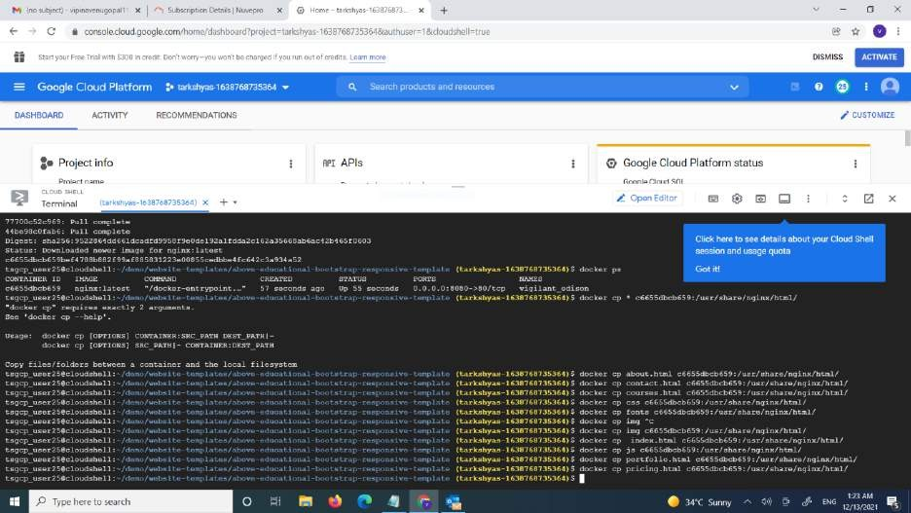

* Docker ps the command is used for seeing the container information
* For committing the container we used docker commit code
* Then push the imaged to the container

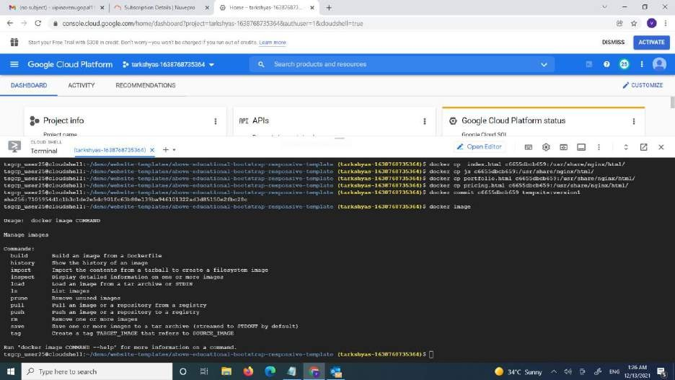

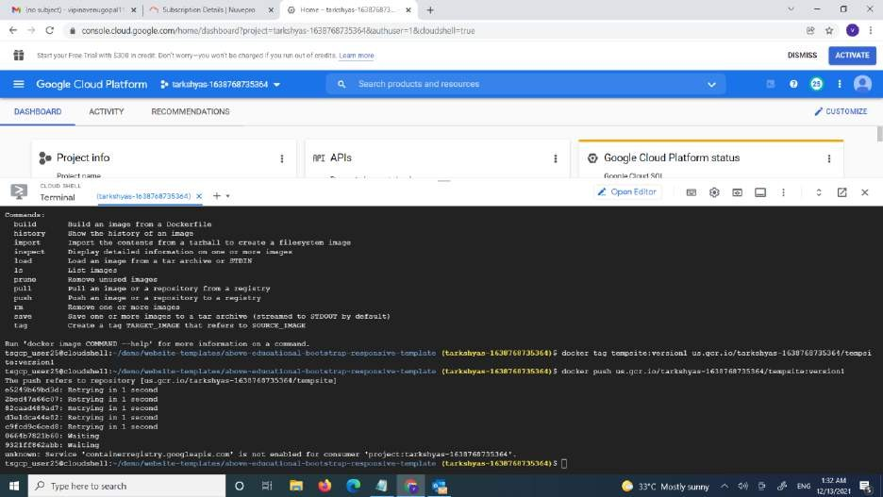

* Go to container registory we can see that a container is registered

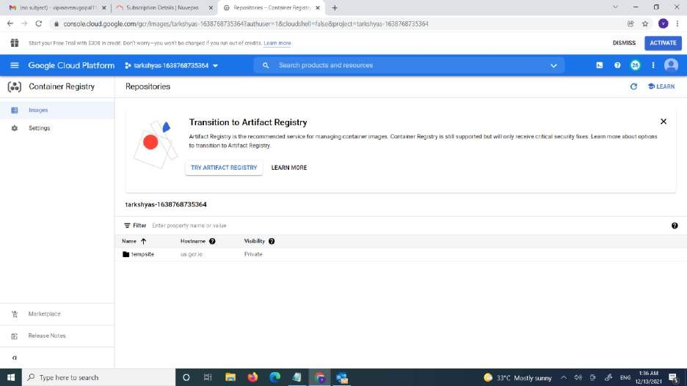

* Click on the deploy to GKE

• 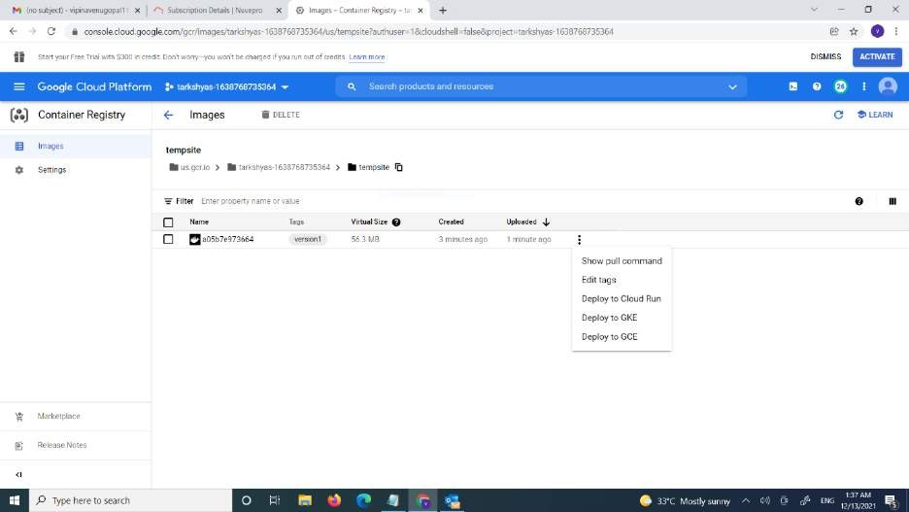

* Deploy the kubernet engine.

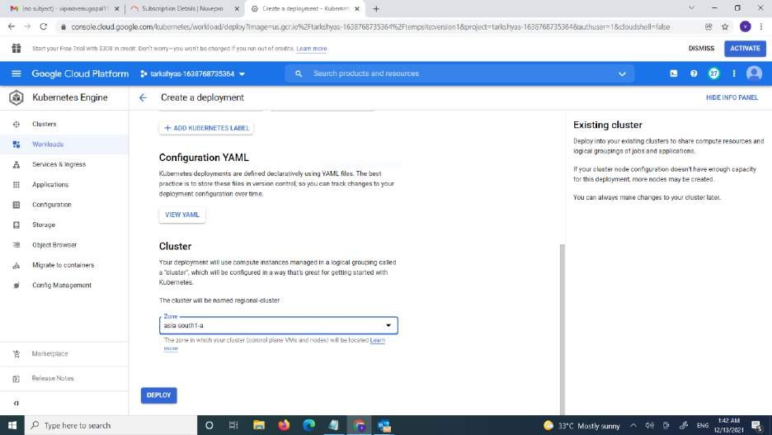

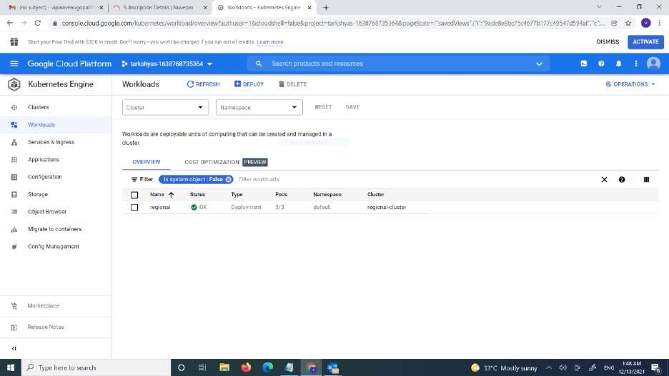

* + **we** can see the cluster is created

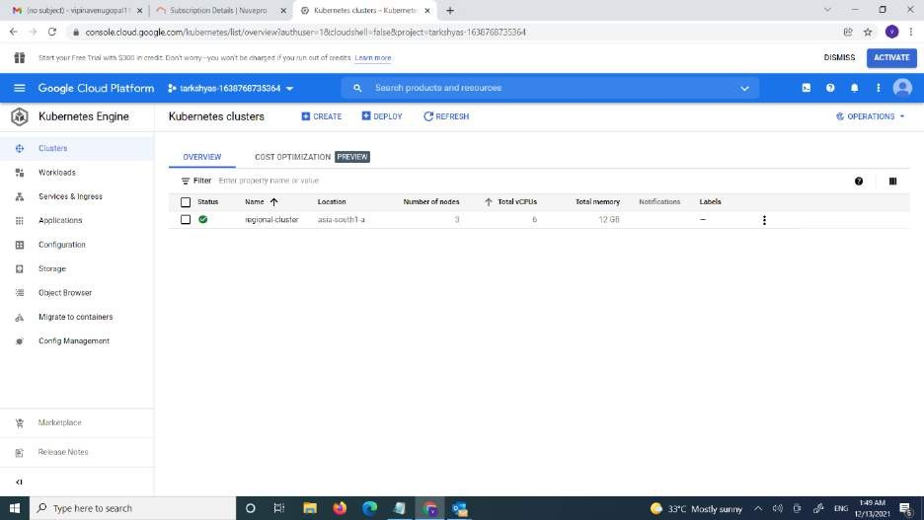

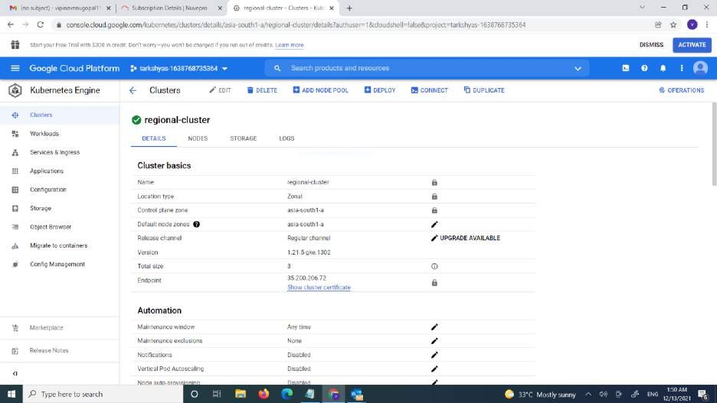

* + the website is hosted using kubernete engine.



# Ansible

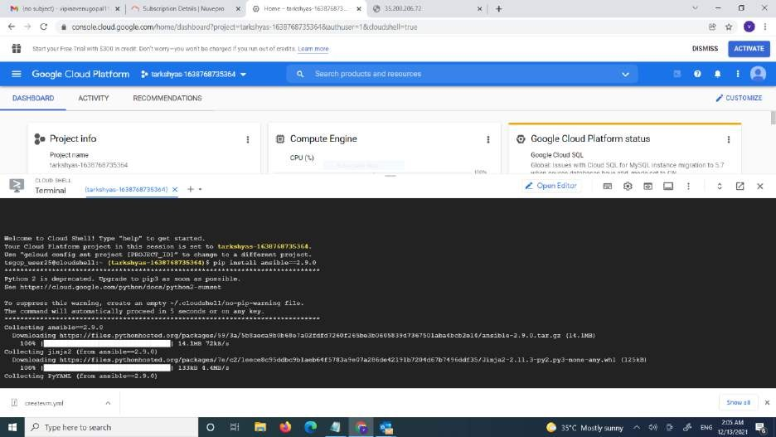

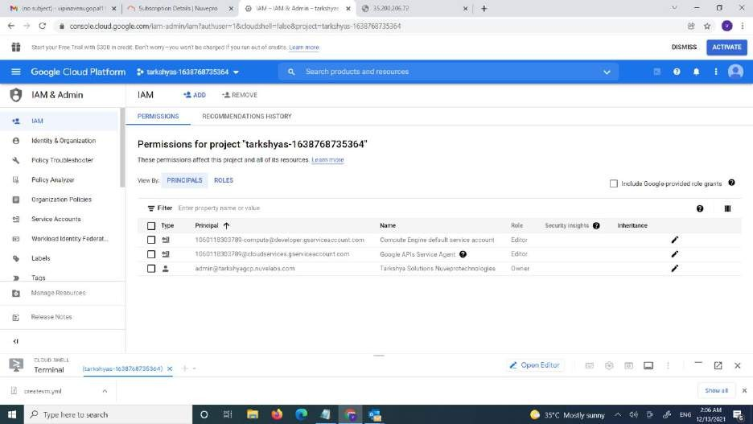

* + first we want to create a service account

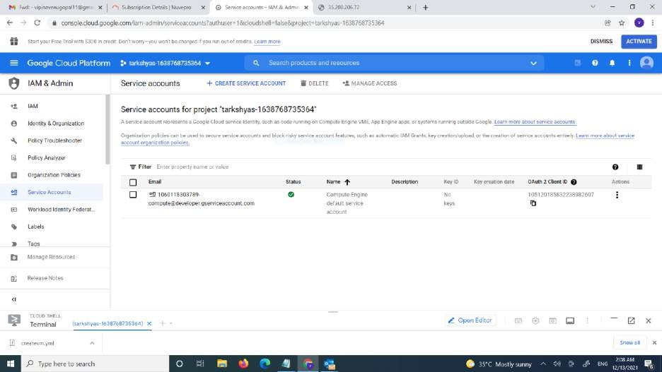

* + click on create service account
  + give the name and give the role as project owner

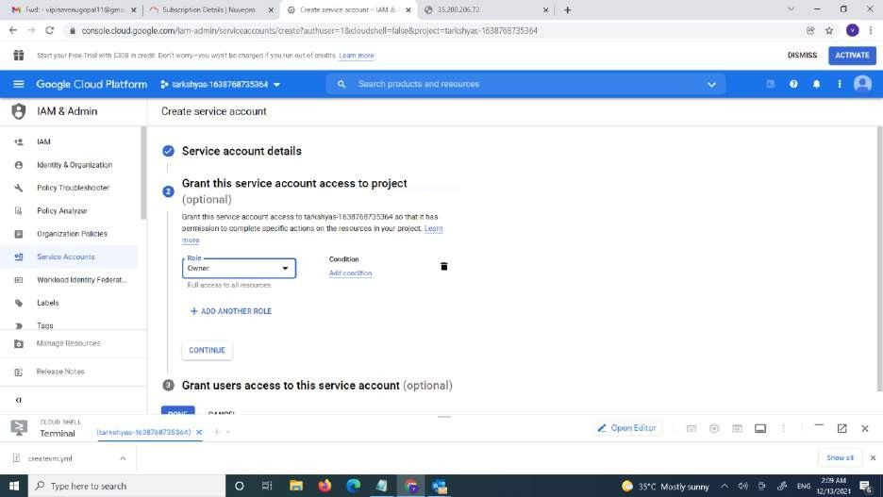

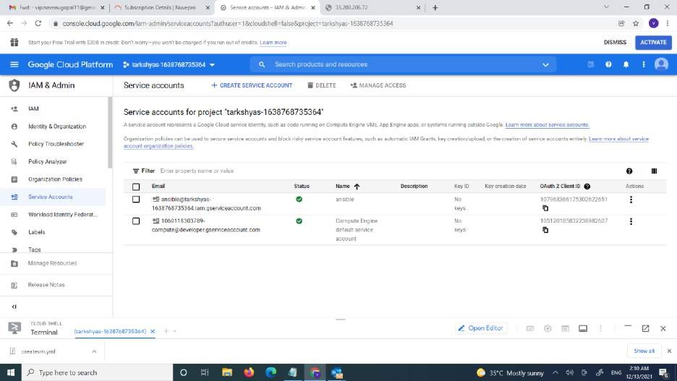

* The service account is created

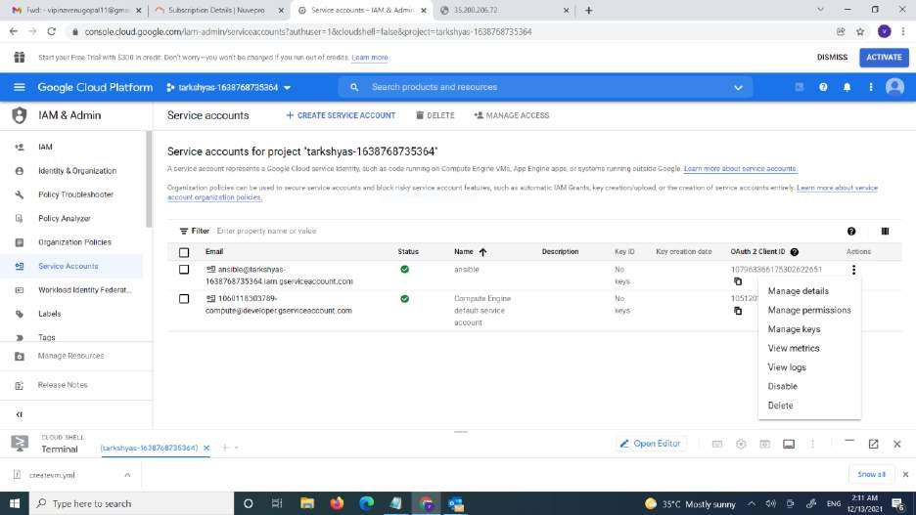

* Click on manage key icon.
* Add key

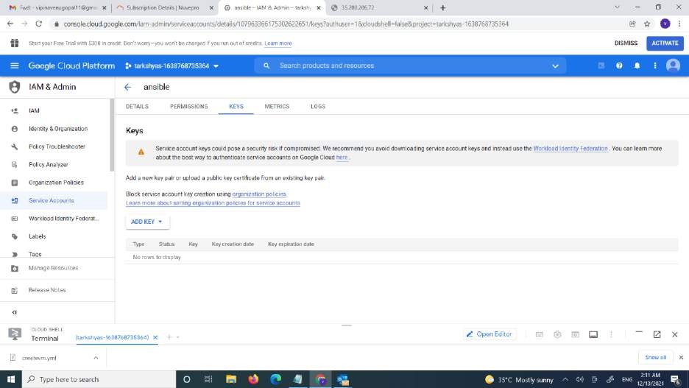

* A json file is created

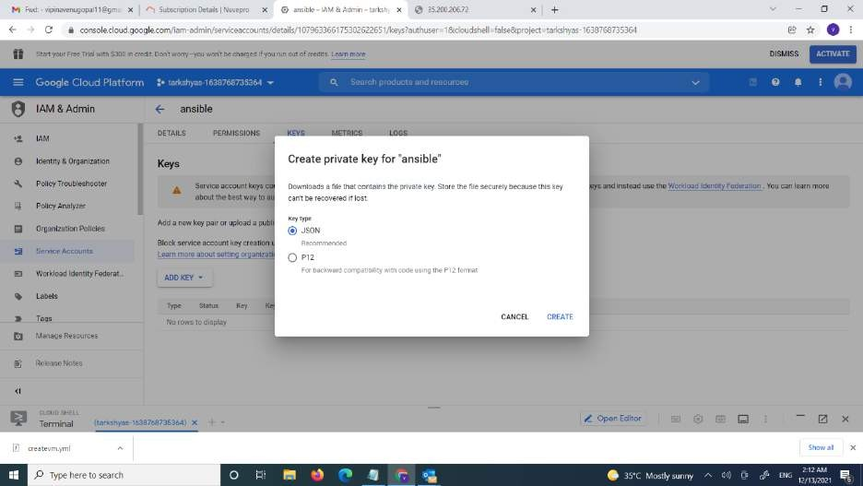

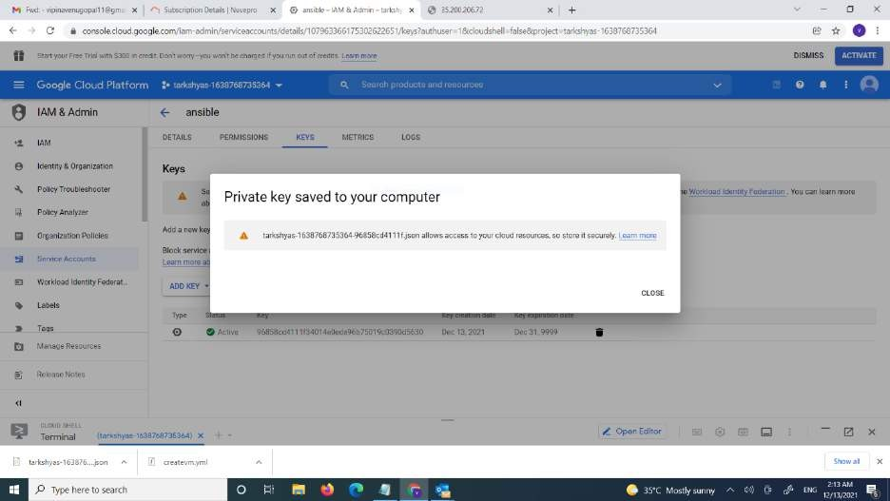

* Install ansible 2.9.0 version using the command-pip install ansible=2.9.0

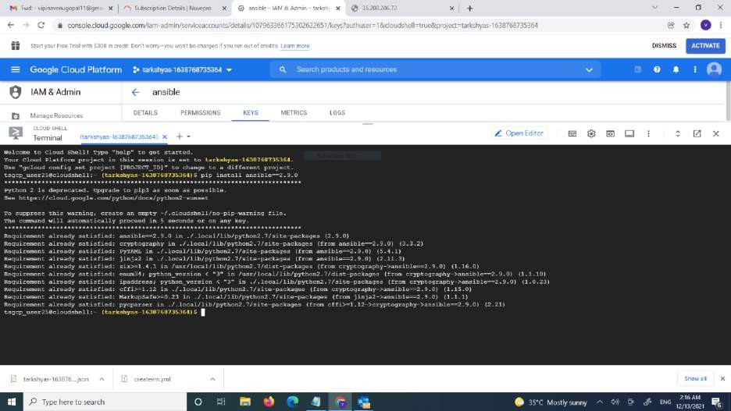

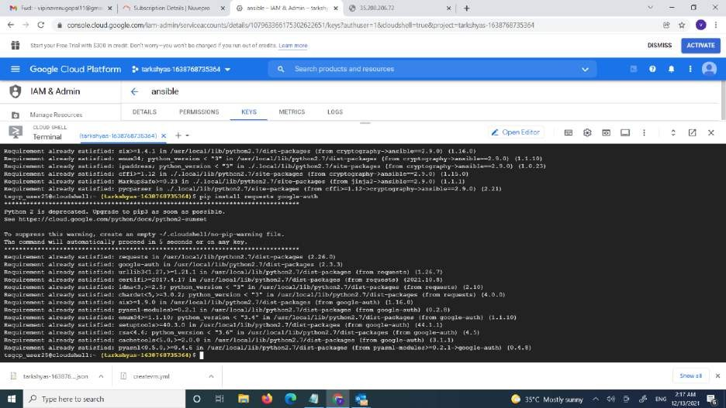

* Upload the ansible file and json file in cloud shell

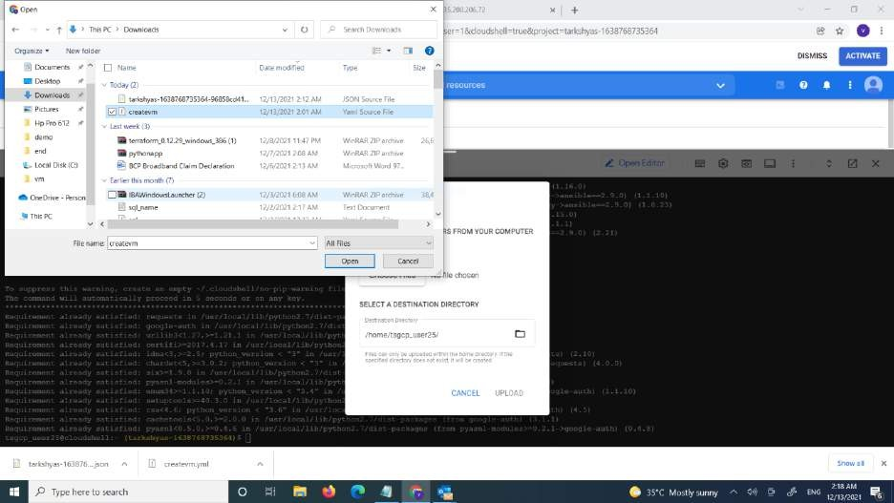

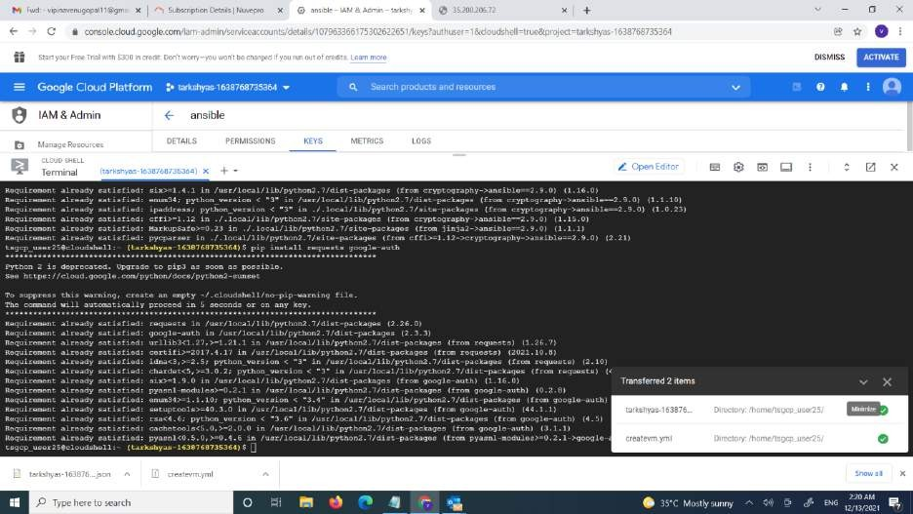



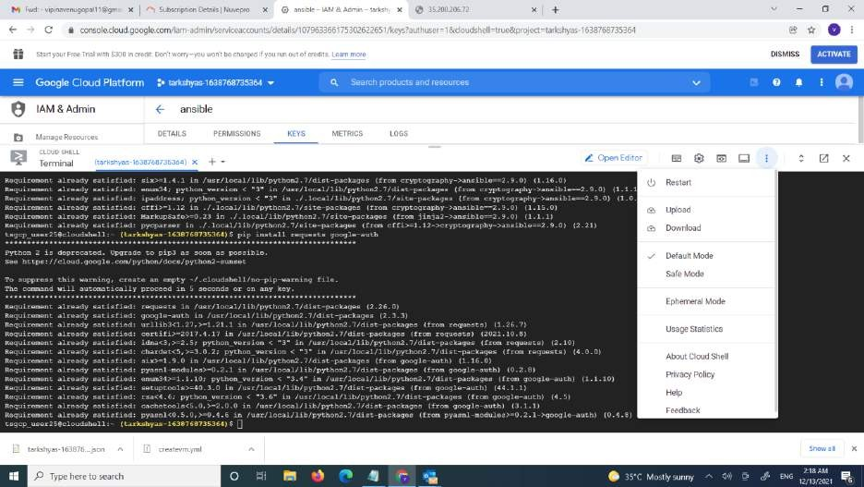

* This is the ansible file for creating vm instance

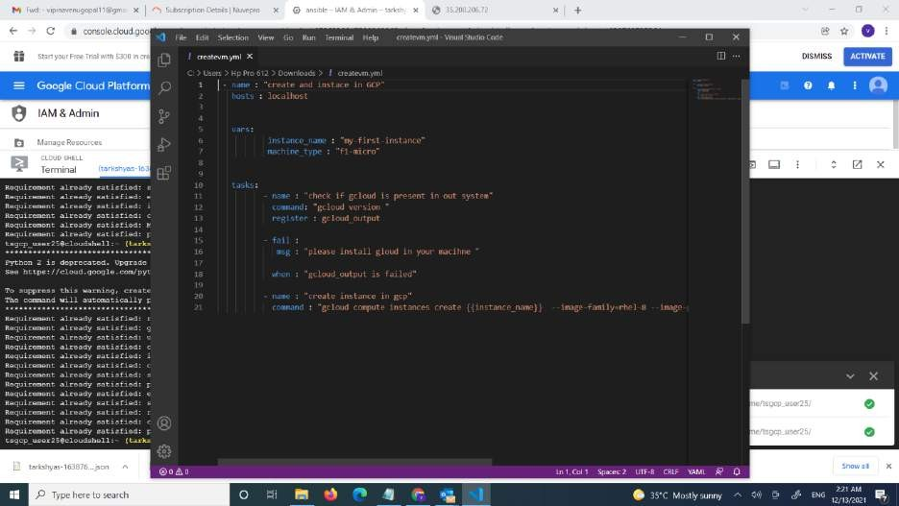

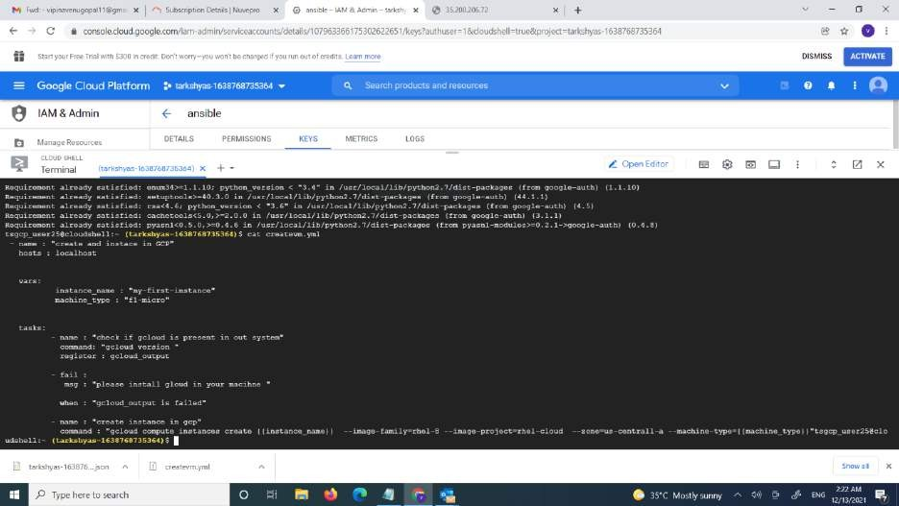

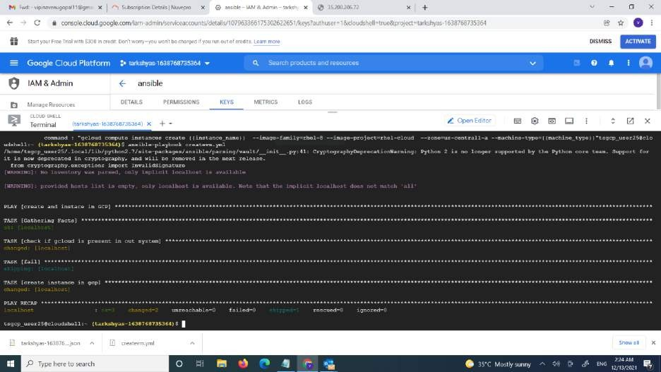

* Now we can see vm is created my-first-instance

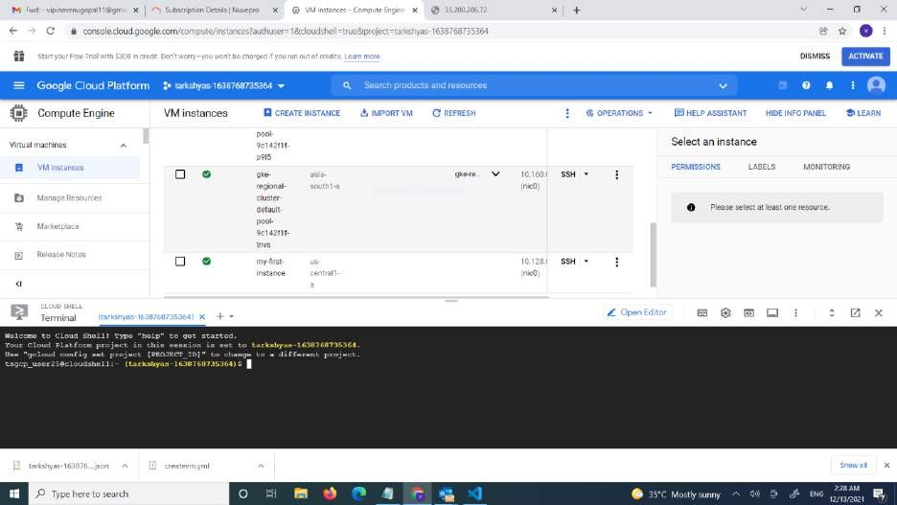

# Cloud function

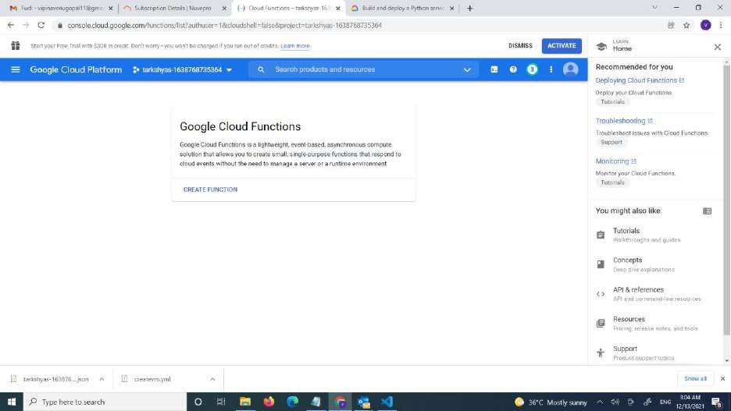

* Click on create function
* Give name to the cloud function
* Select trigger as http
* Click on save and then create

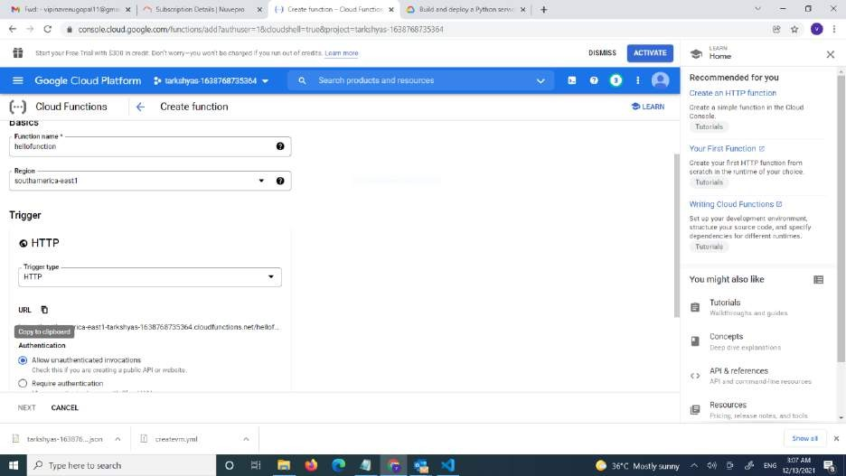

* Select python 3.9
* Then ebable API and click on deploy

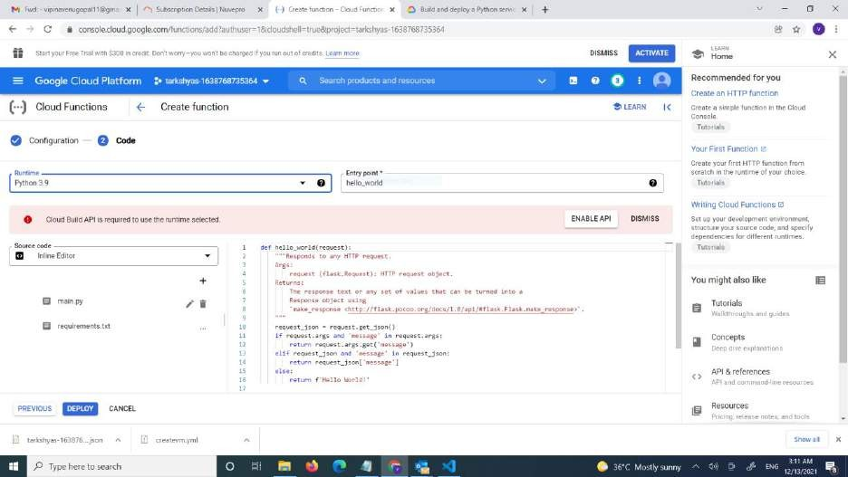

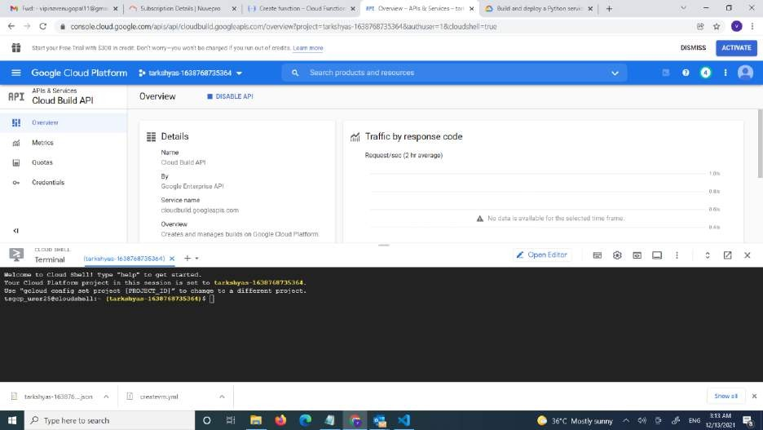

* The cloud function is created

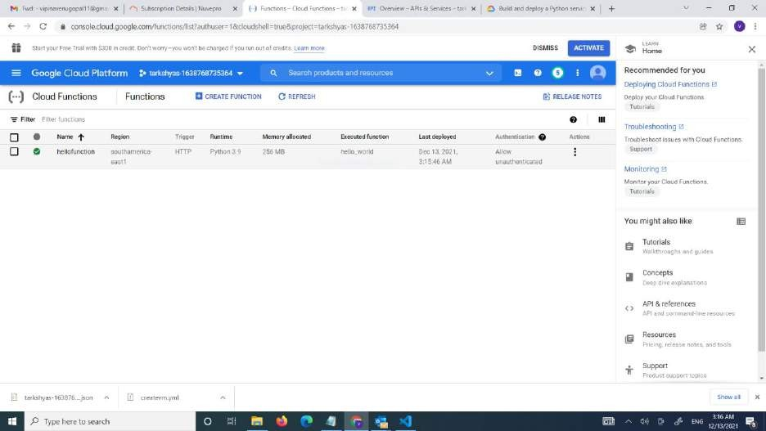

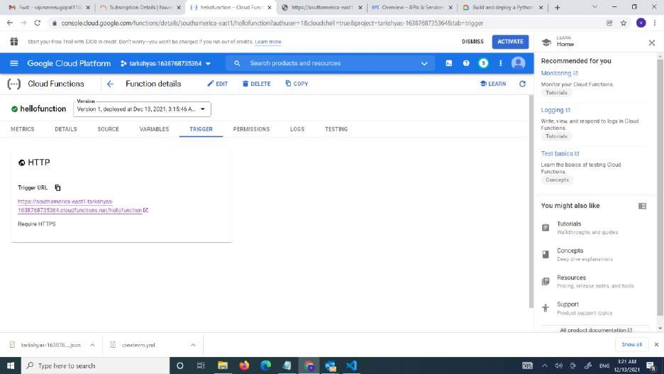

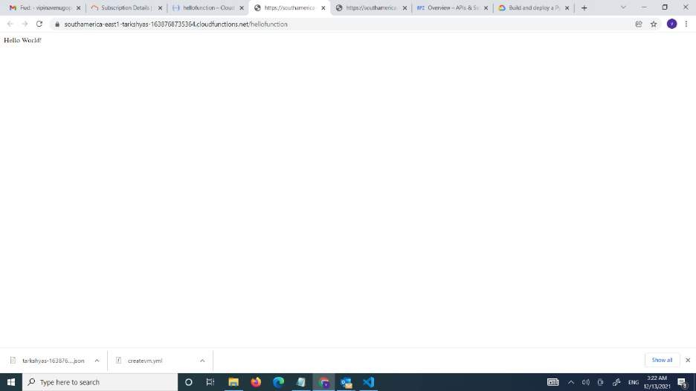

# Load balancing

* First we want to create instance template
* Click on crete instance template

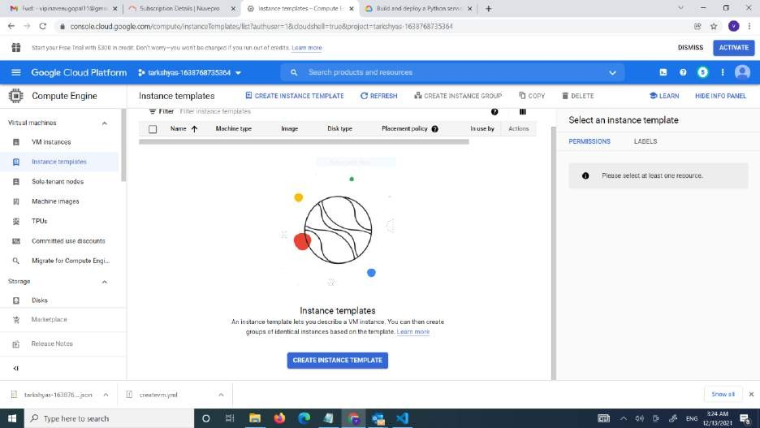

* Give name ,region and 1GB cpu for the template

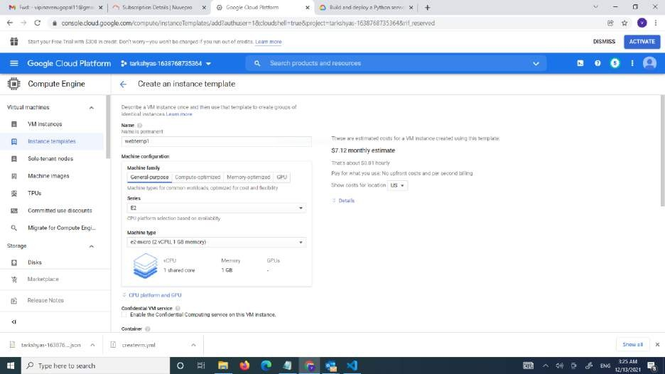

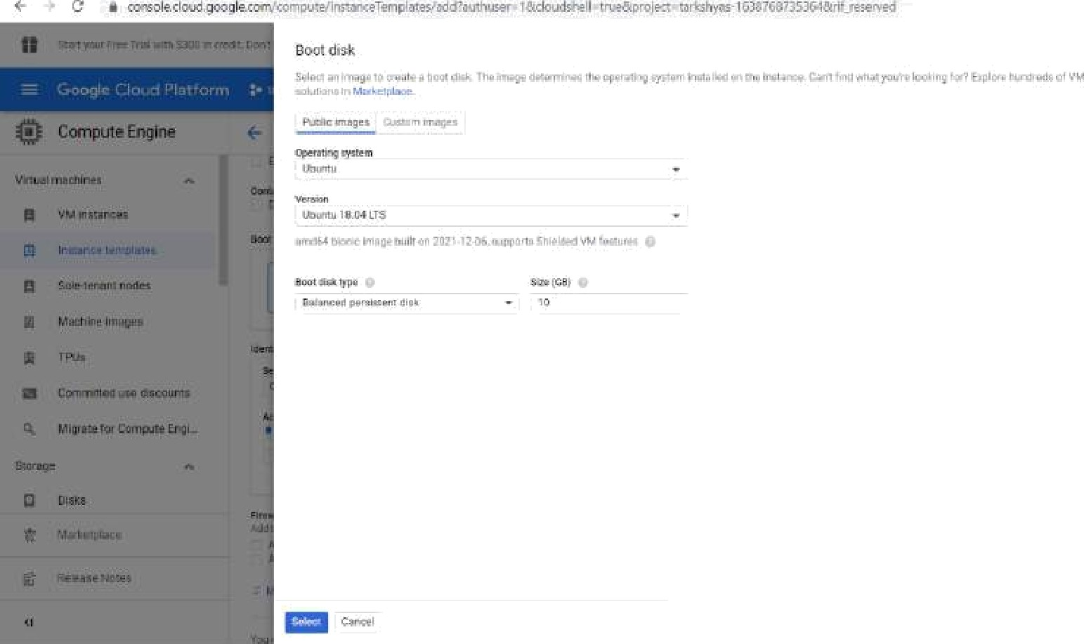







fkxnpute Eiigiñe + Create an instance terrgilale

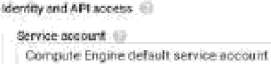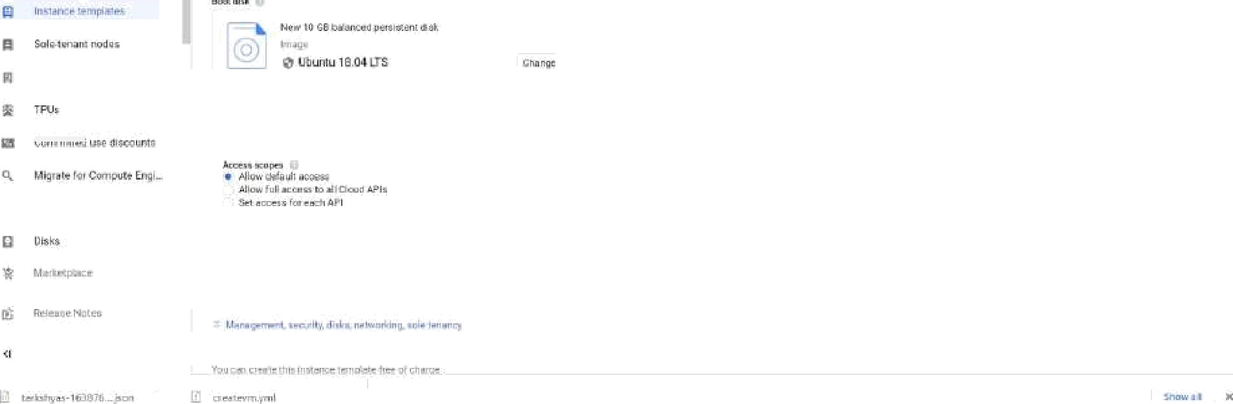



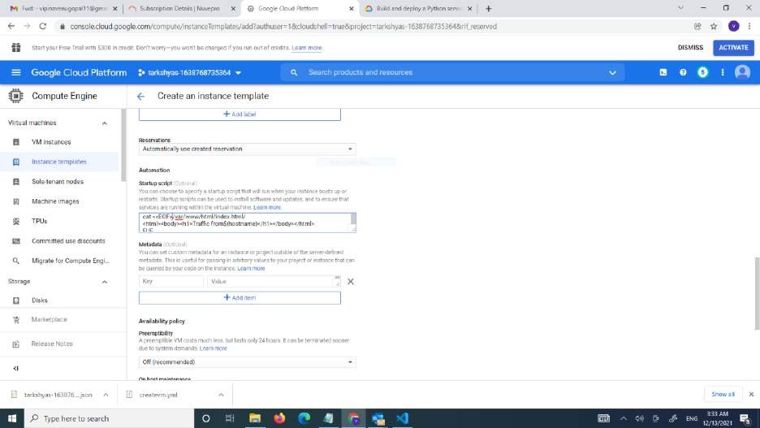

* Now the template is created

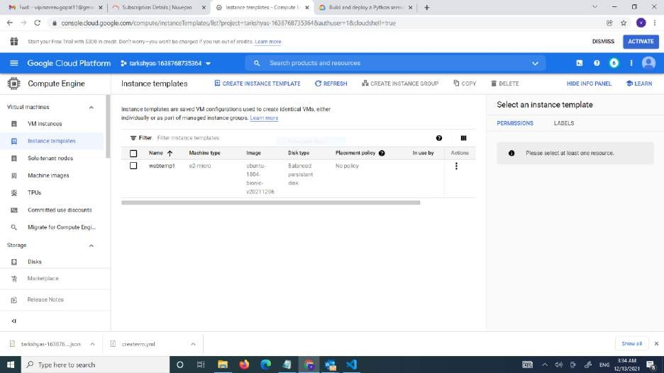

* Now want to create instance group
* Click on create instance group

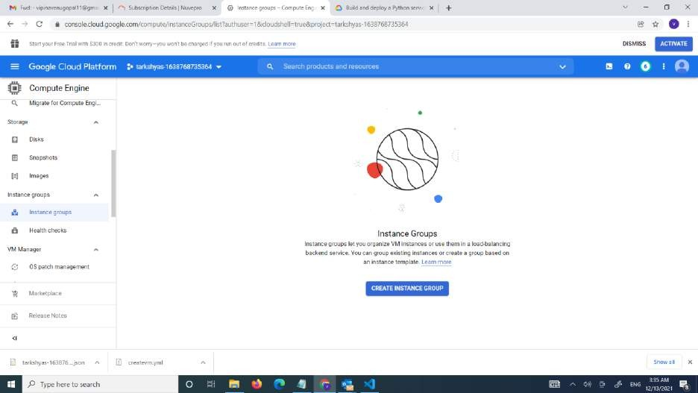

* Give the name for instance
* Turn of the autoscalling . select the no:of instance 2

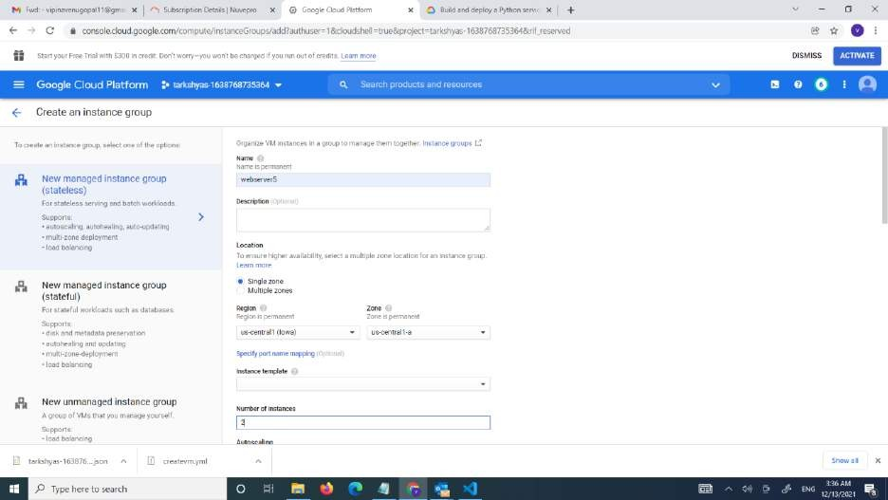

* Create auto healing and health check

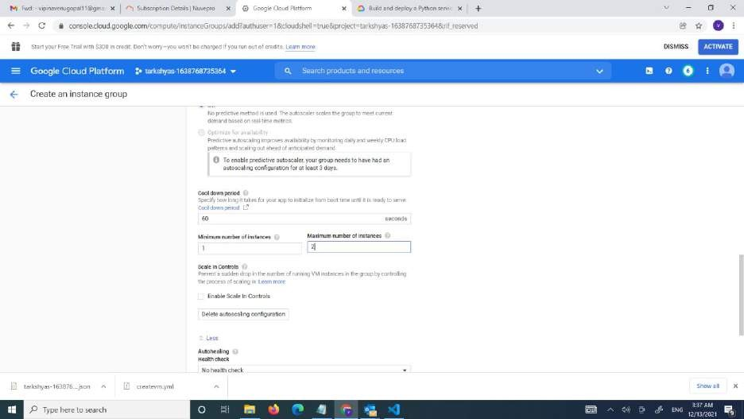

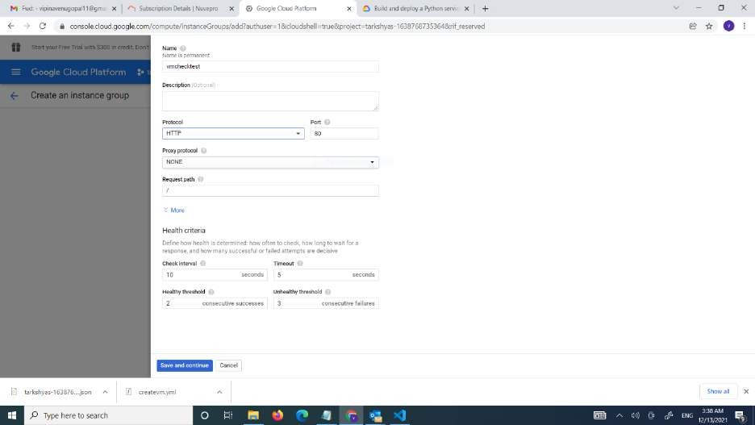

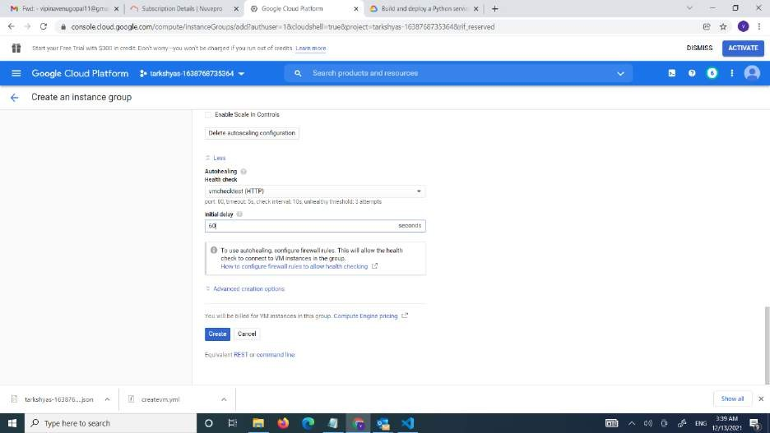

* The group instance is created

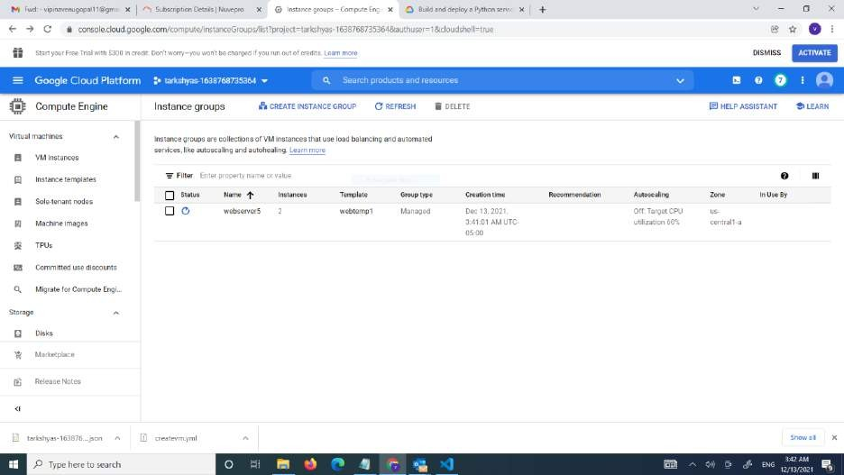

* The vm is also created

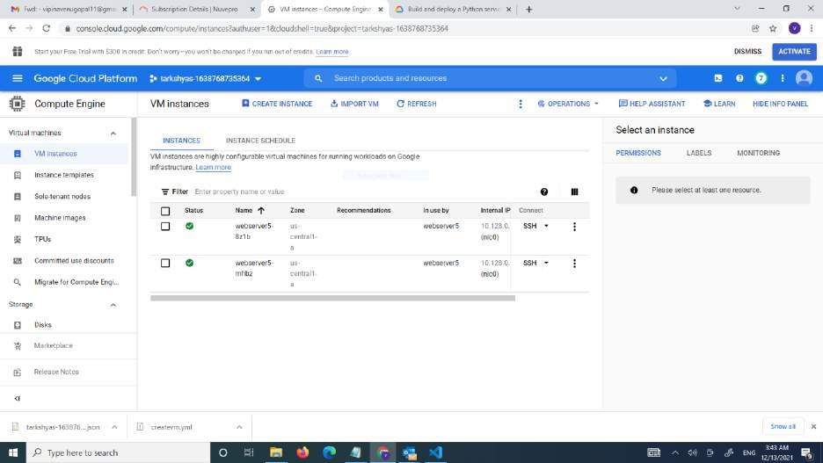

* Create load balancing
* Click on load balancer

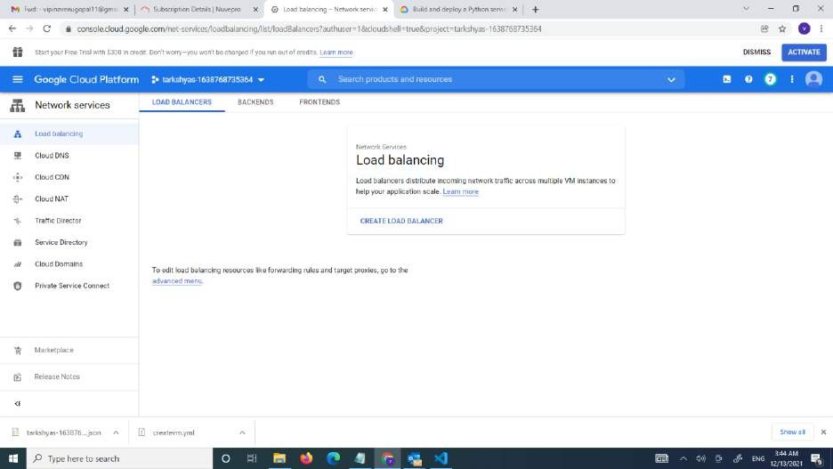

* Select http load balancing

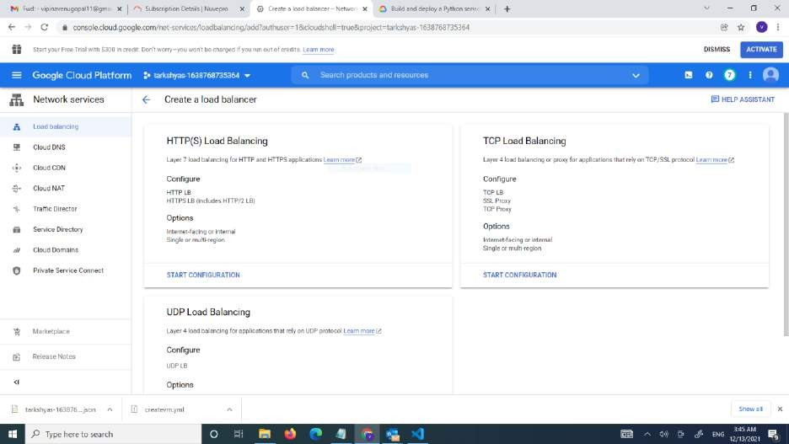

* Give backend and frontent configurations

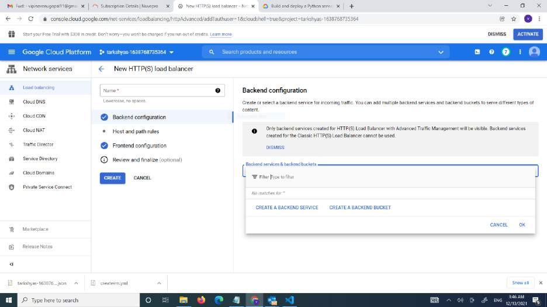



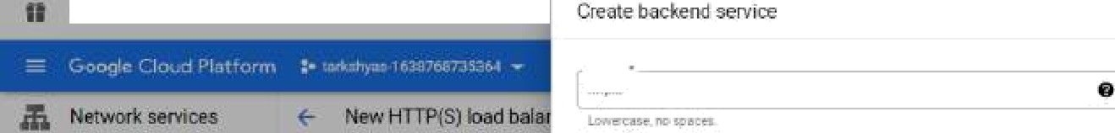

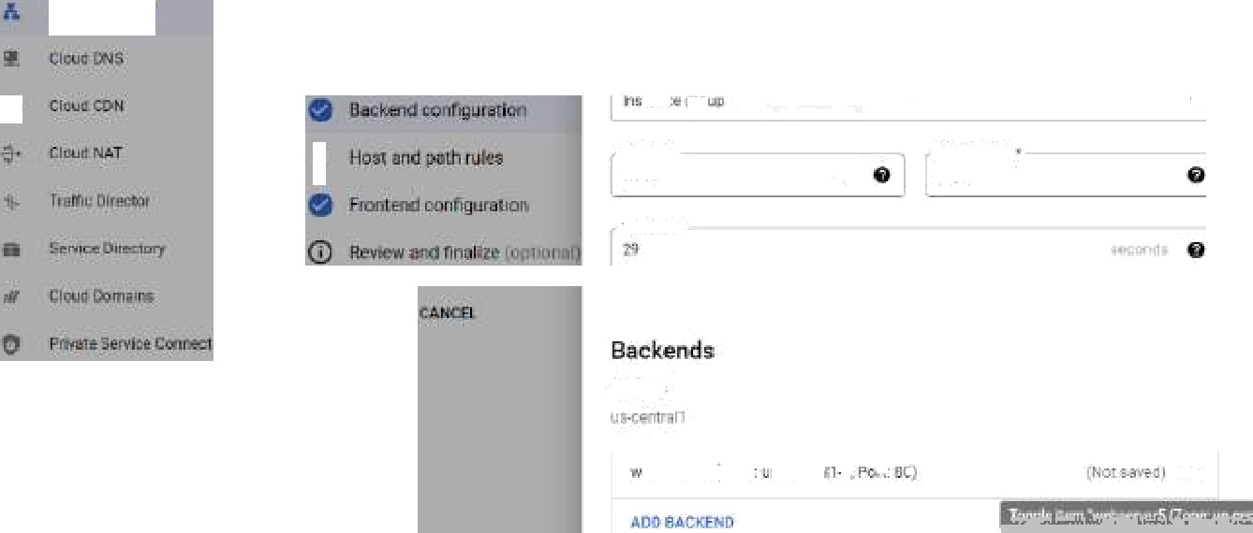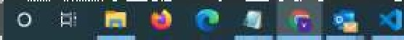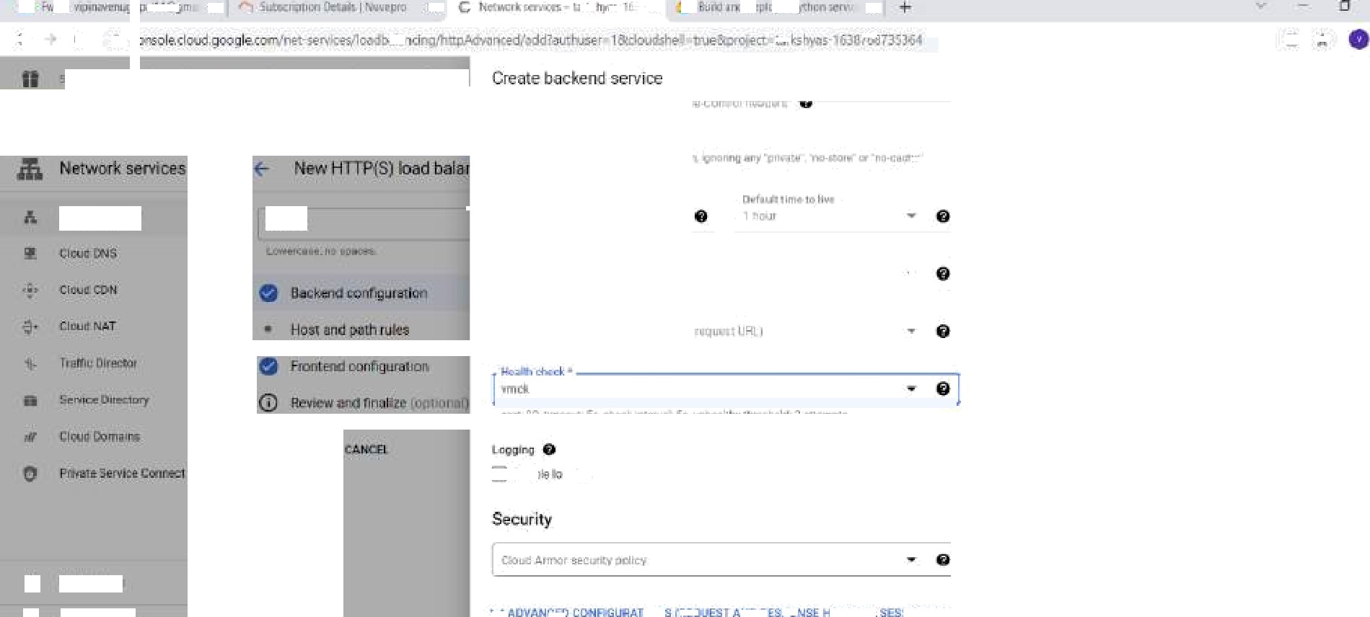

*P* in riere r



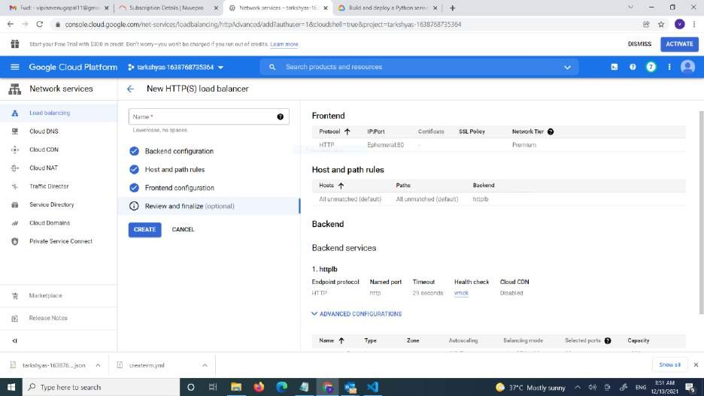

* The load balancer is created

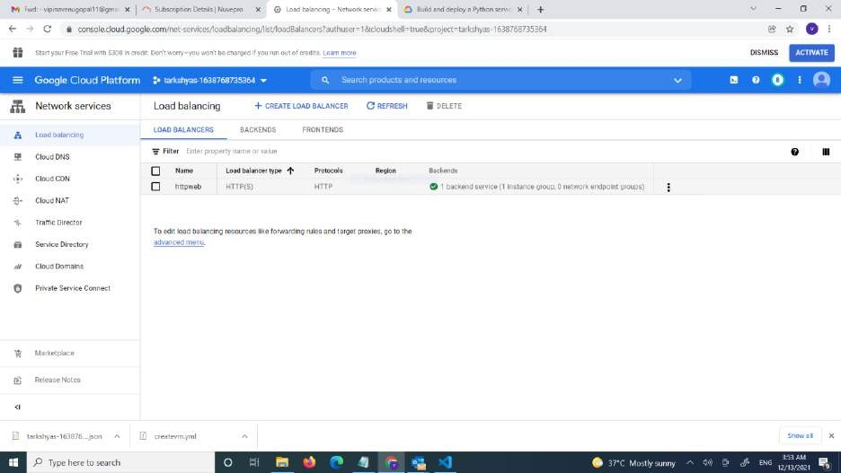



Comp]eEngine 



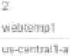

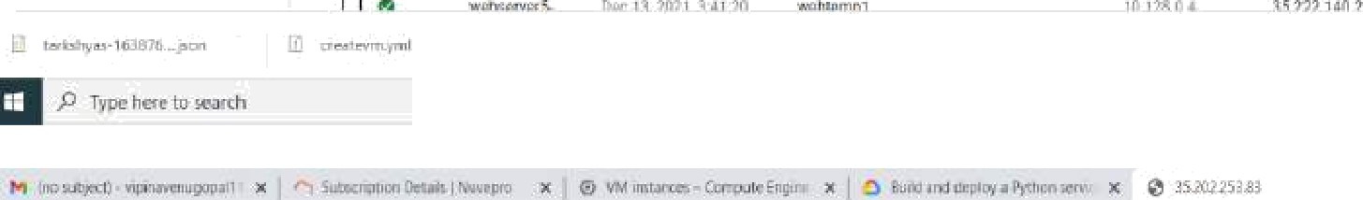

• +

Traffic from webserver5-4142

*P.* in here to wren

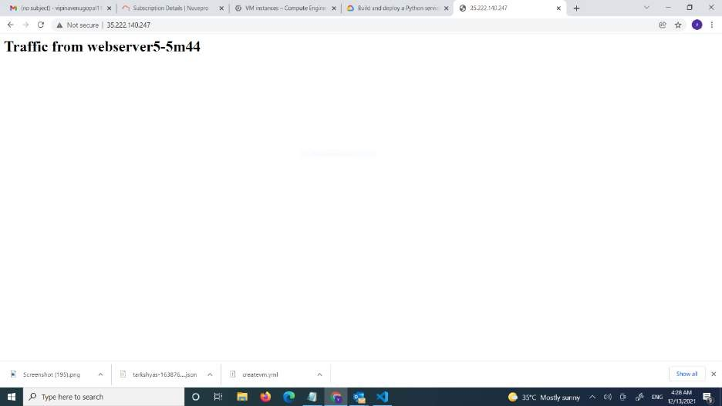

# Create a VPC network to communicate between 2 VM instances present in different networks

* Create 2 vpc networks
* One is created in asia soth 1 region and the 2nd one is created at the us central 1 region
* Create subnet for each vpc network

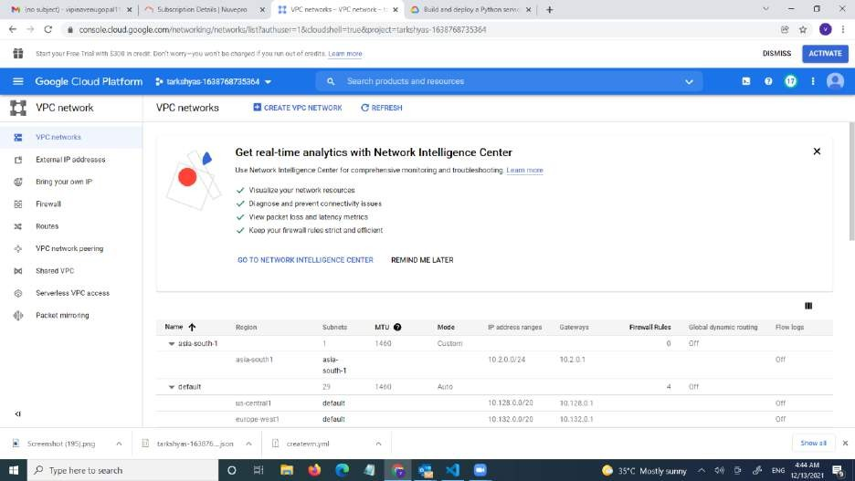

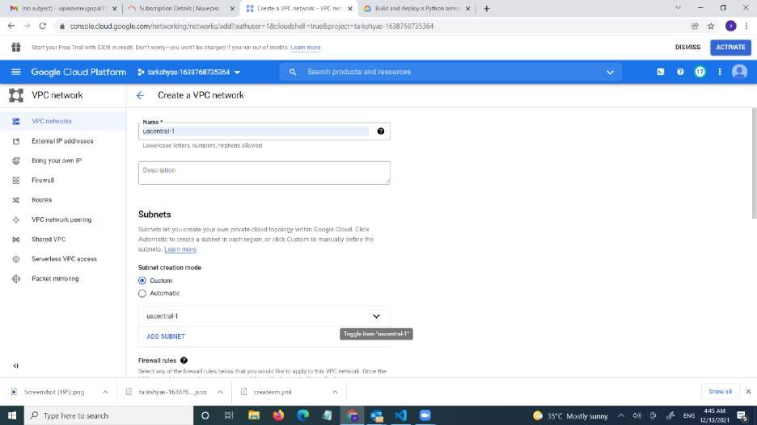

* The 2 vpc network are created

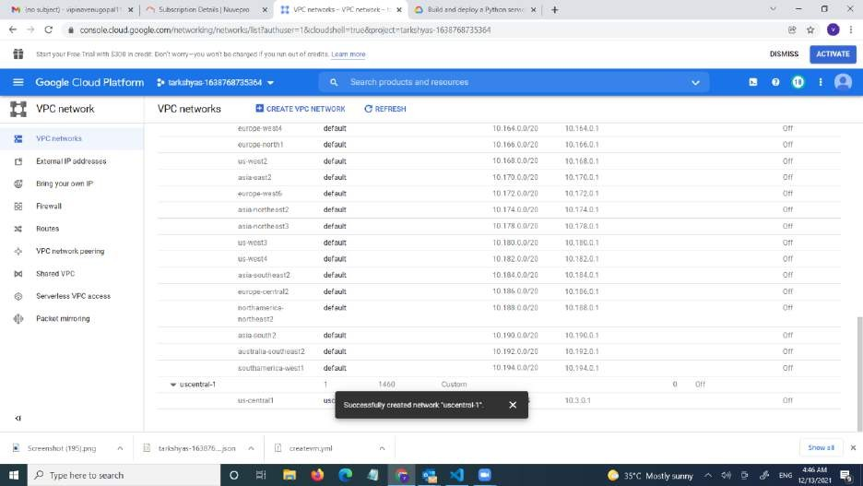

* Now we want to create vm instance

• 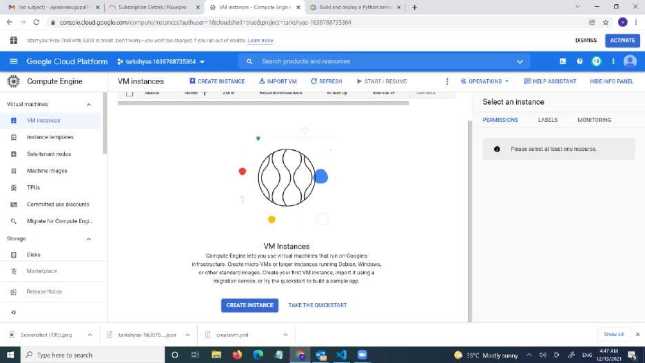

* Creating asia-soth vm

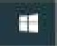

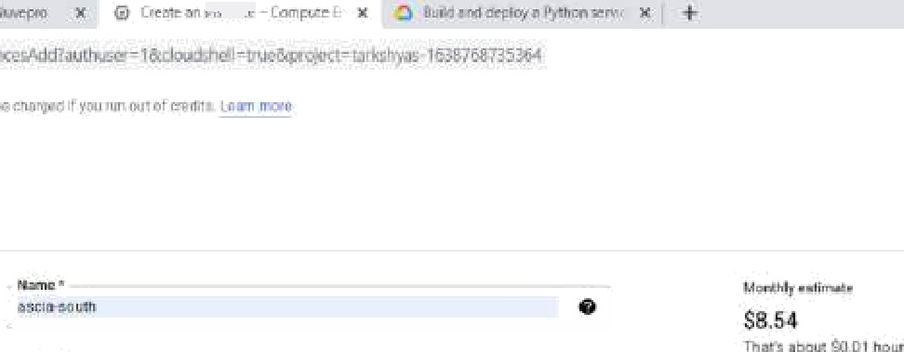

+ Greate en instance

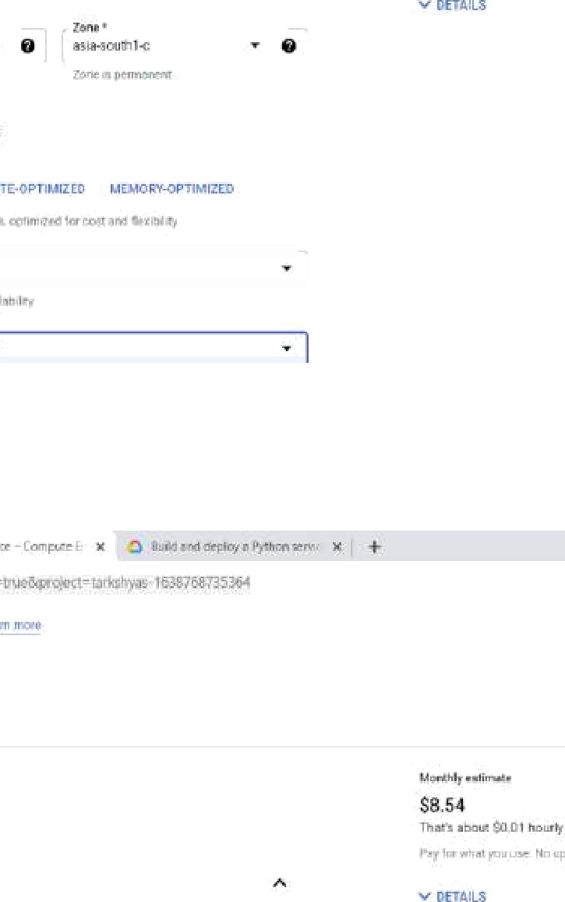

Machine conflgcration

+ Greate en instance

Netwok interfz+ces B



 

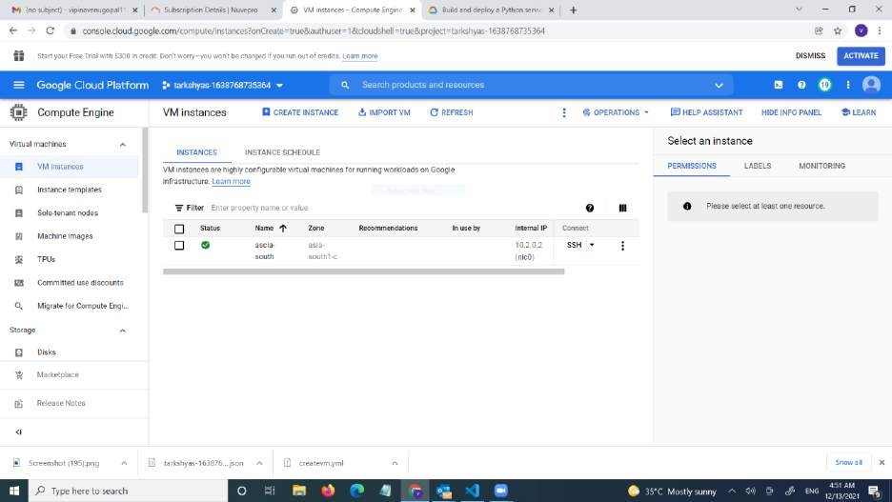

* Creating us-central vm

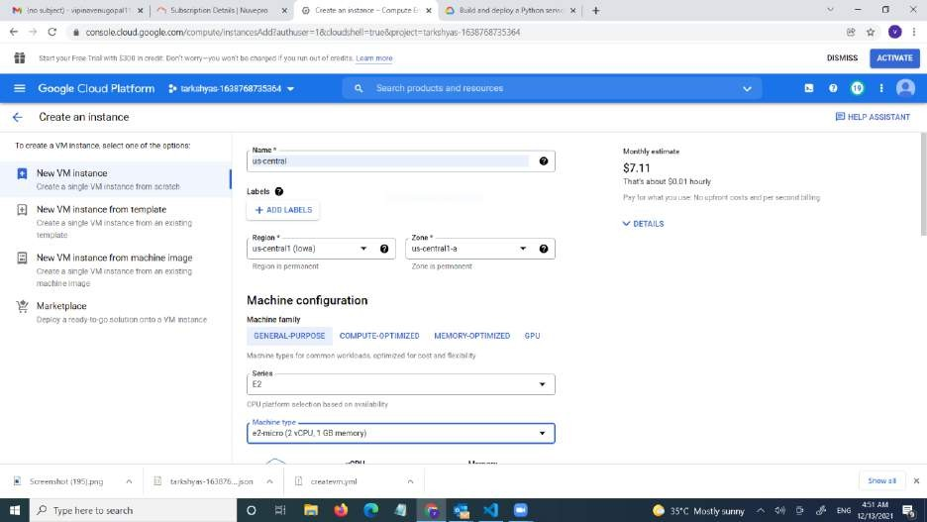

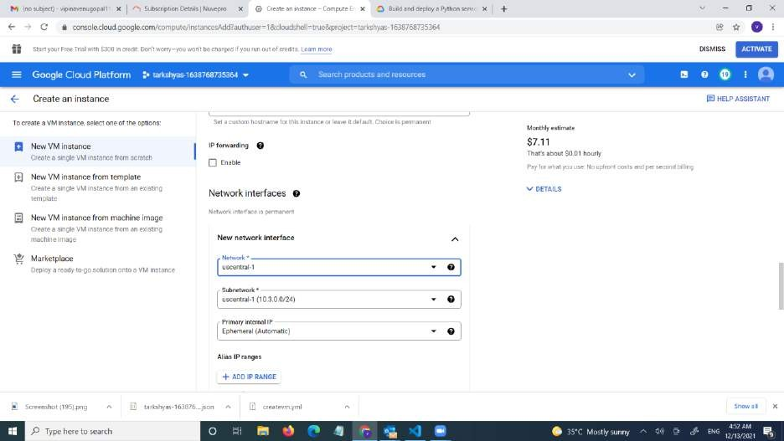

* The 2 vm are created

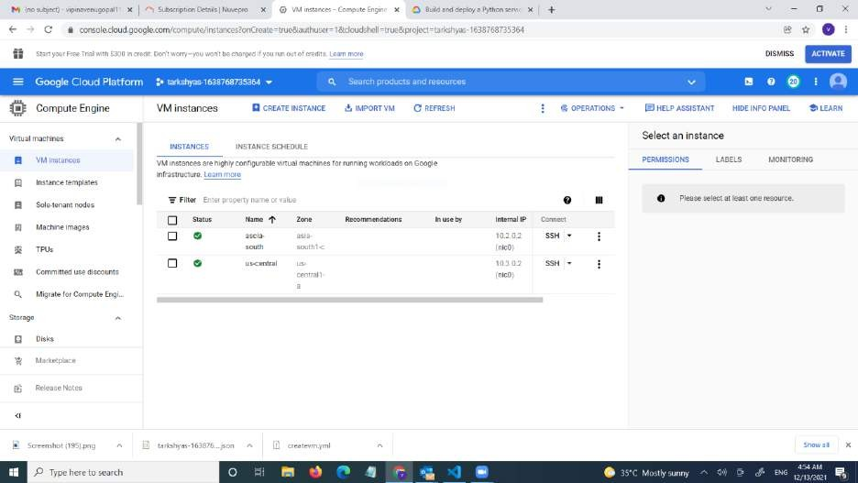

* For the connection we want to add firewall rule for both vpc network

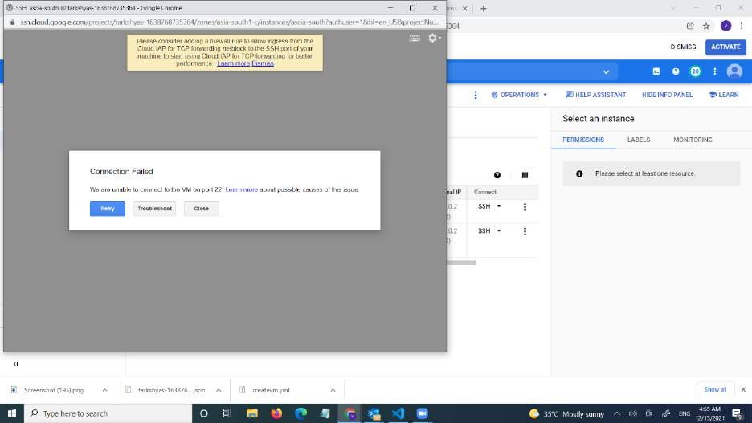

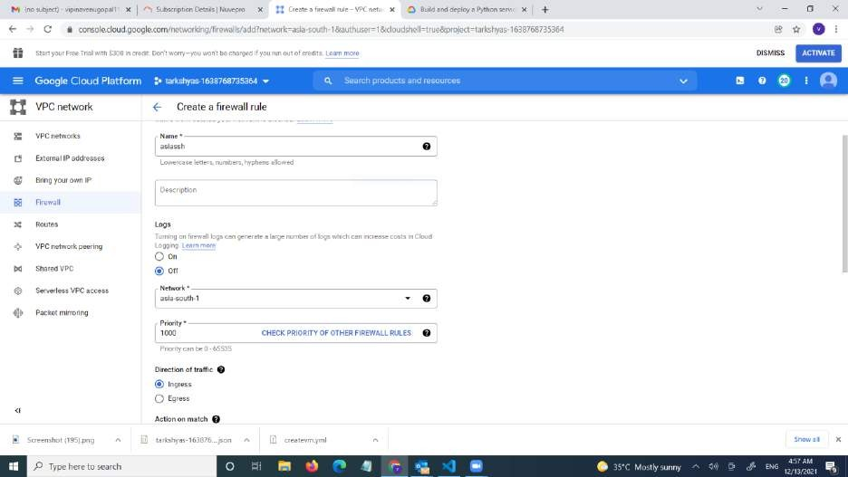

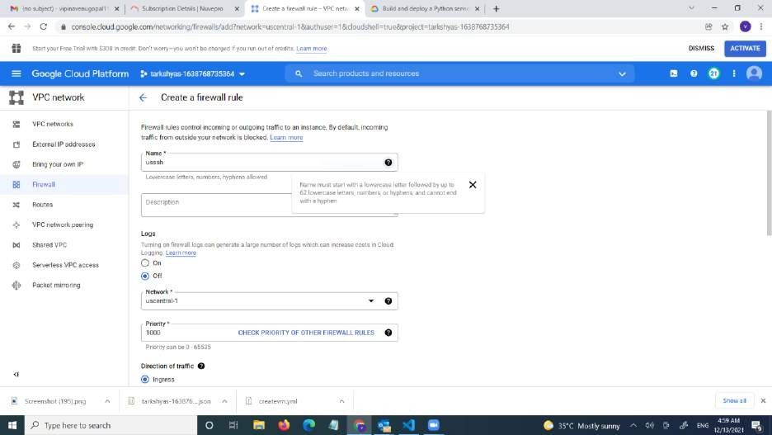

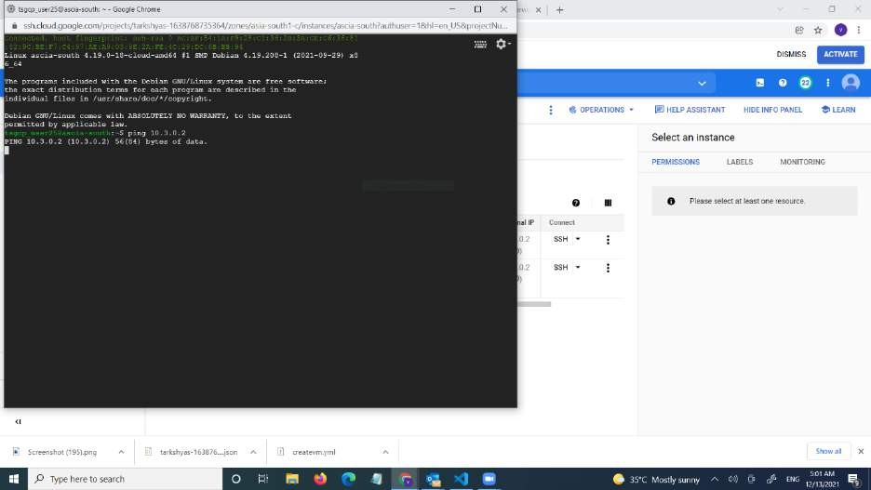

* Then create external IP address





(- Tesewea data address

i n i e







(- Tesewea data address





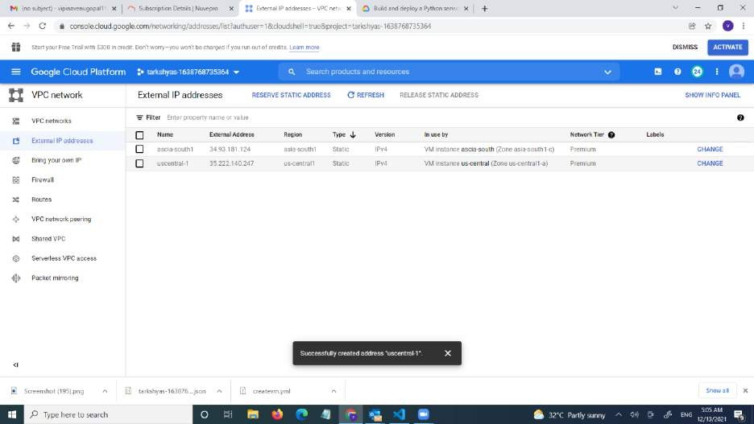

* Create VPN network

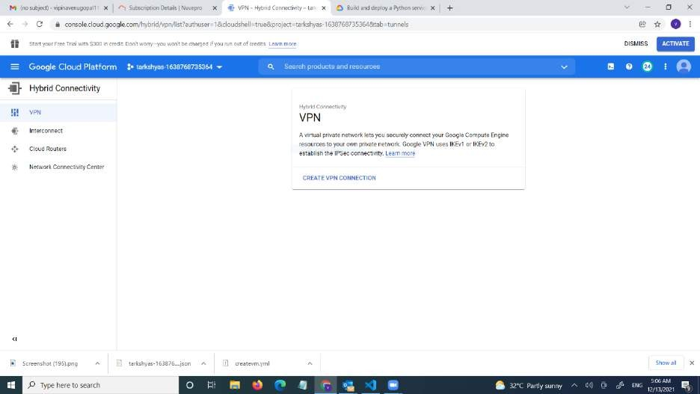

* Select classic vpn

 



6/ I-tybrid Connectivity 6 C:reate B VPN





 # Tyoe riefe to w«t'



6/ I-tybrid Connectivity 6 Greate a VPN c‹xinection

Gaogle Cc<npute Englne VPN gateway









@/ Hit+id Connectñnty I- Greate g VPN CmnBction





 *P..* in riere to wr‹n 



@/ Hybrd Cannectivity £- Oréate a YPH axinectiofi

Tunr s 0



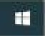

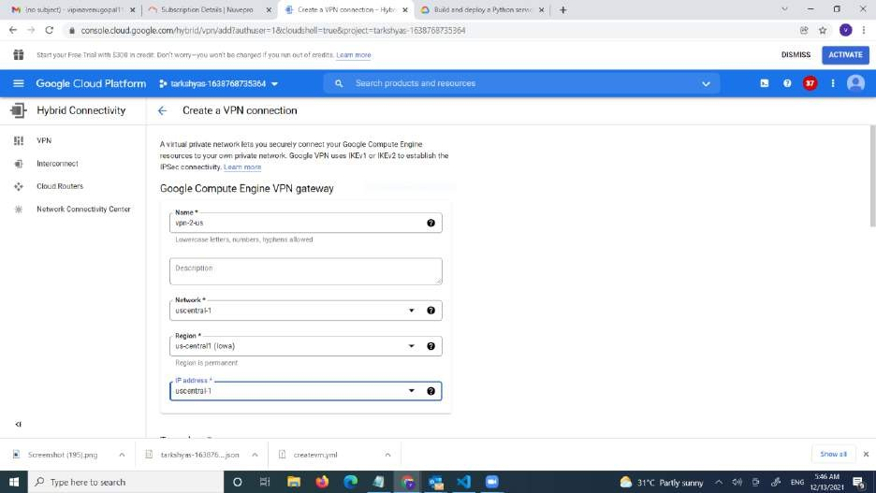

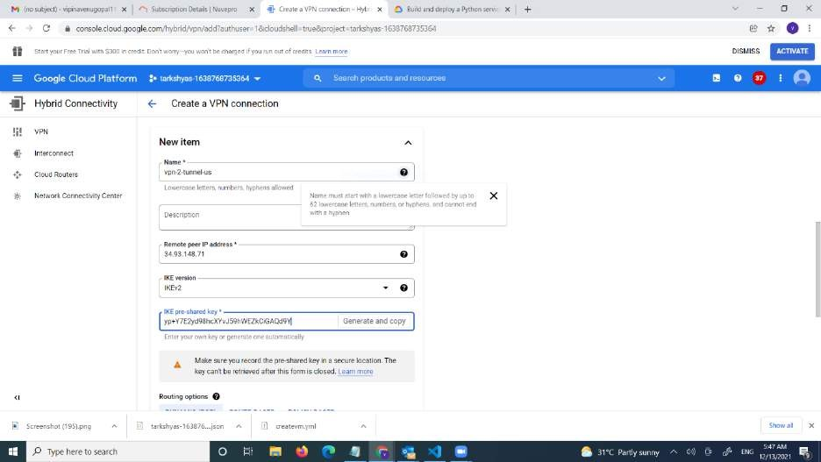

* The 2 VPN network is created

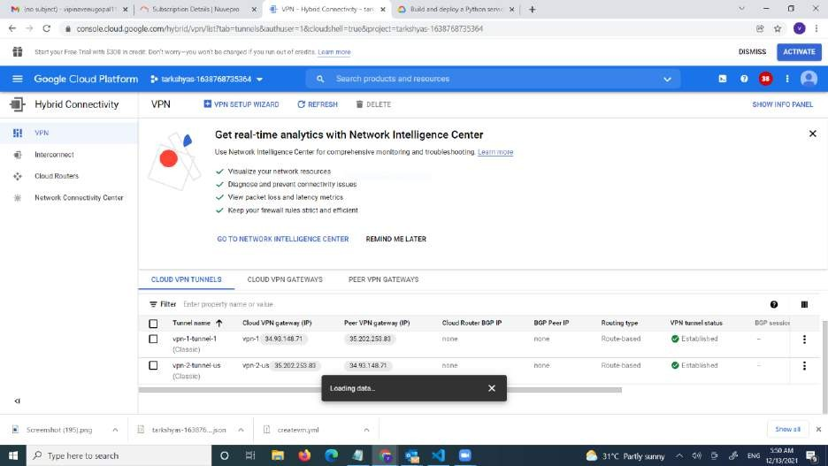

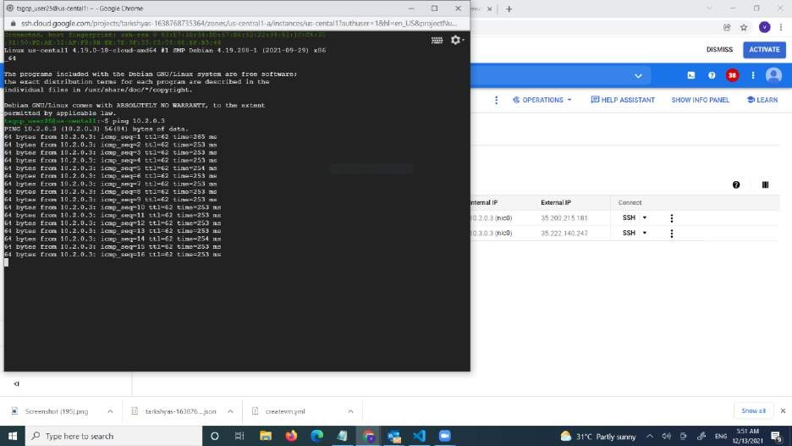

* Created a VPC network to communicate between 2 VM instances present in different networks

# Big query

* BigQuery is a serverless , cost-effective and multicloud data warehouse .
* Creating a database college .

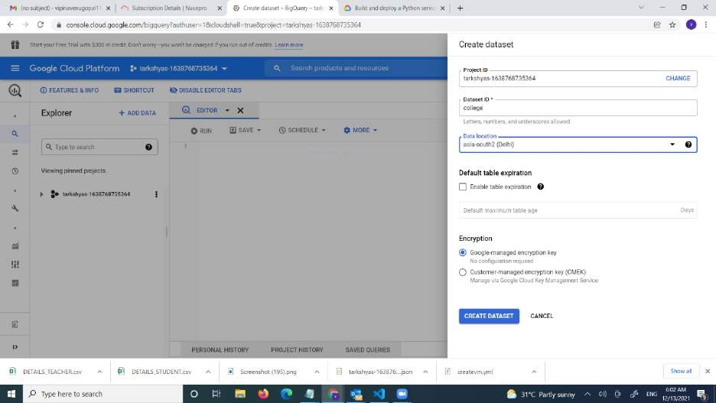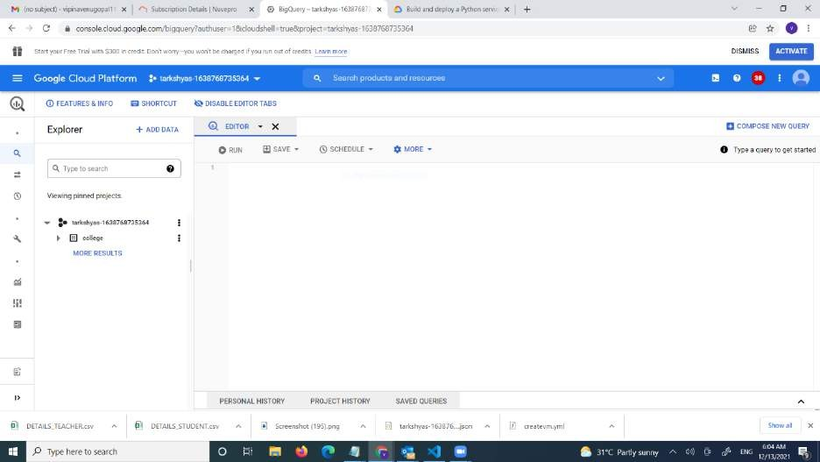

* Creating a table student.

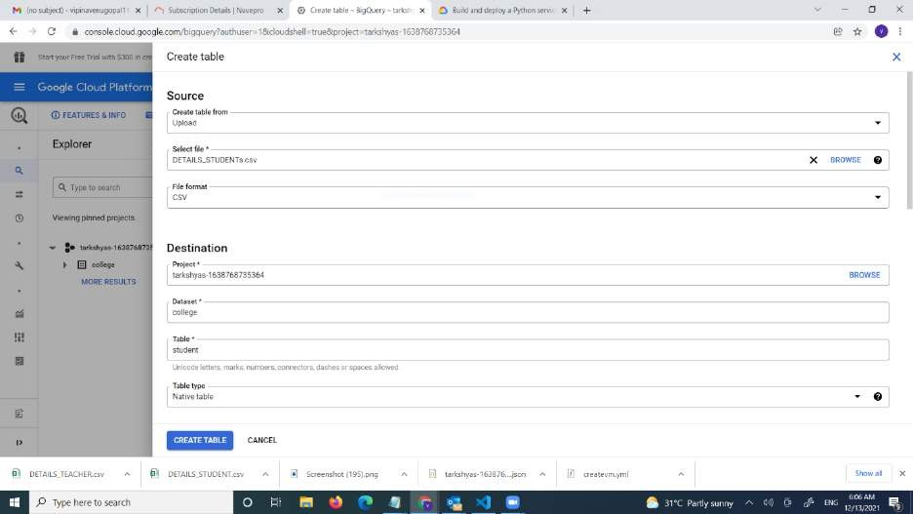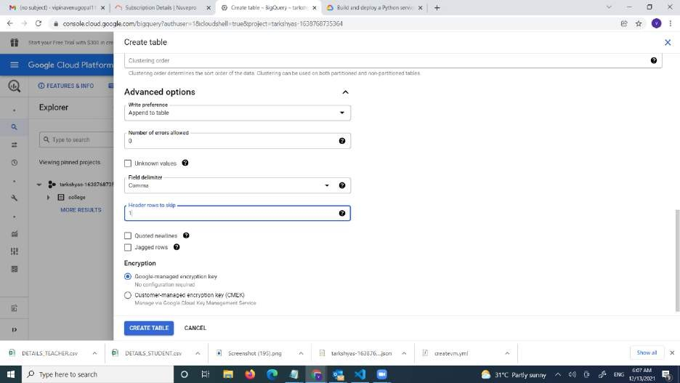

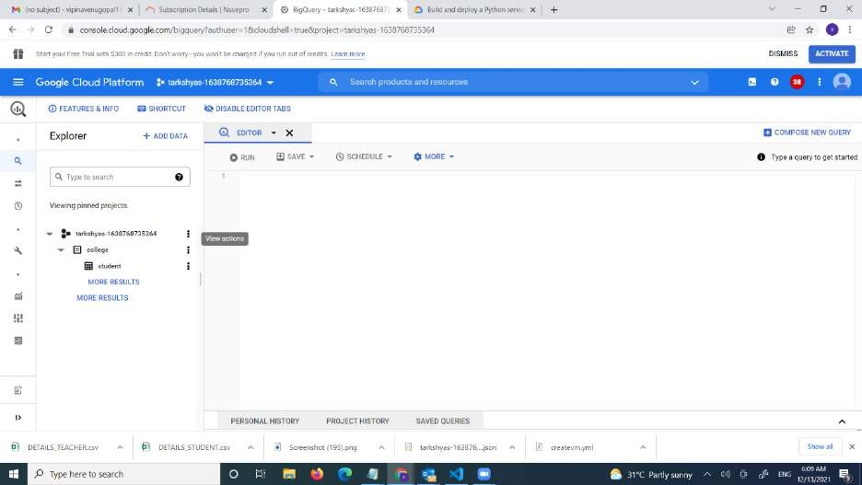

* Also created a table teacher

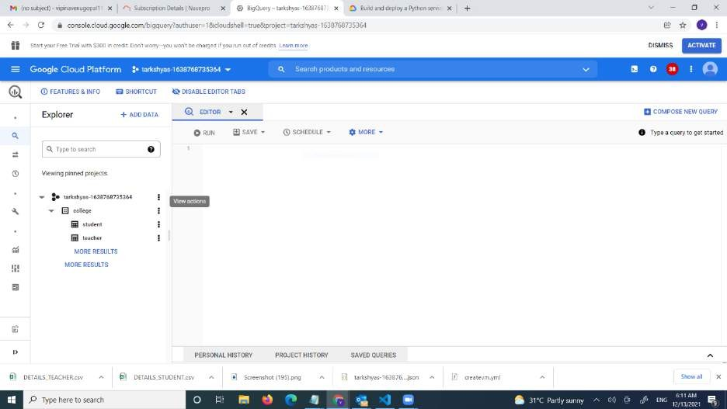









B student







- x n









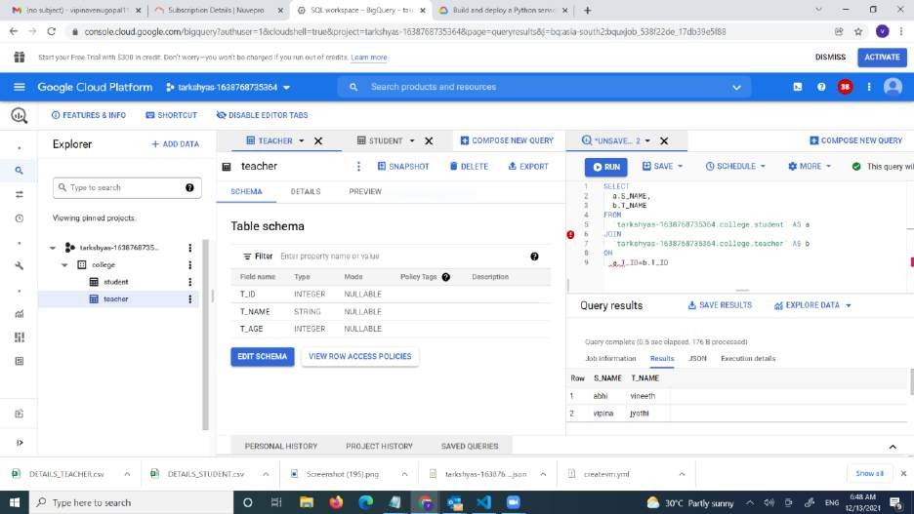

* Big query ml gwicklabs .
* Click on the first site
* Click on the below link

•

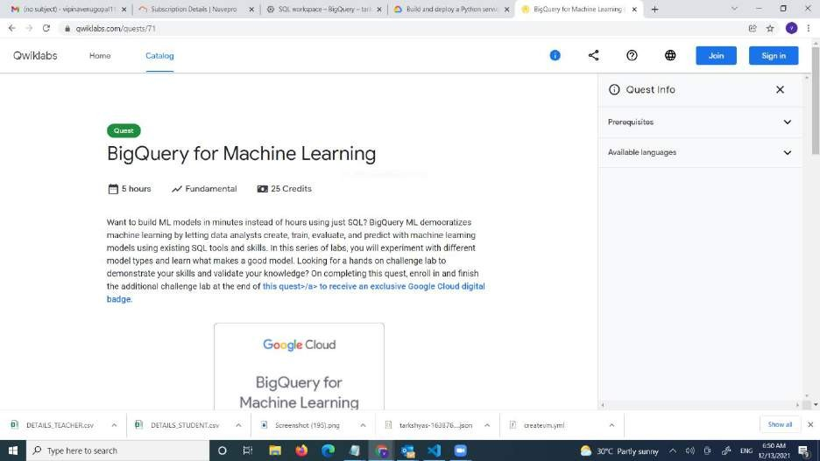

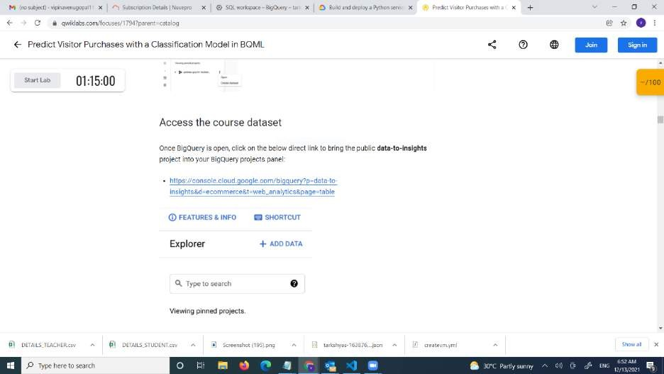

* We can see the data base is created

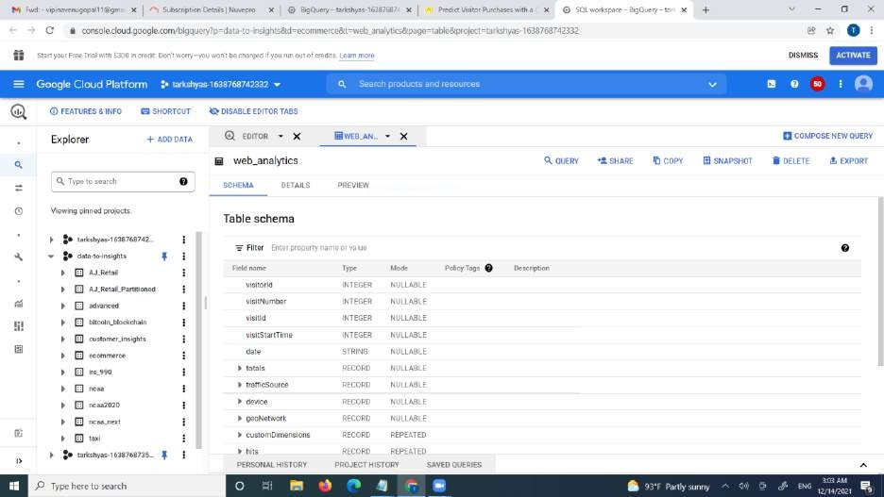

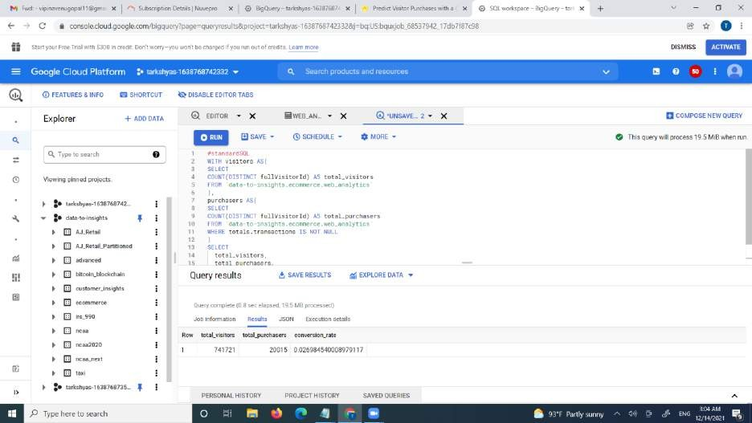

* Created a data base machine and a table temp_data

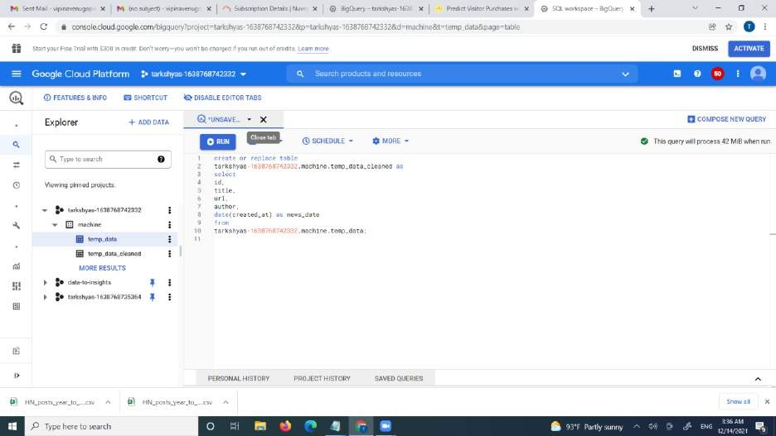

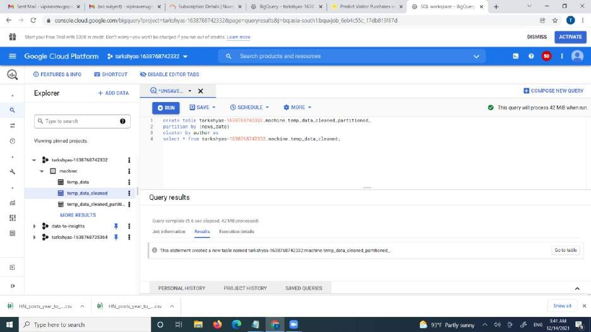

# DNS

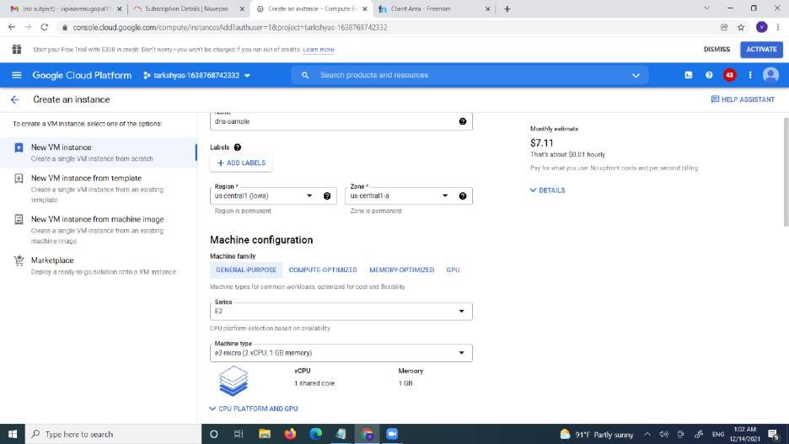Creating a vm instance

Set up the script

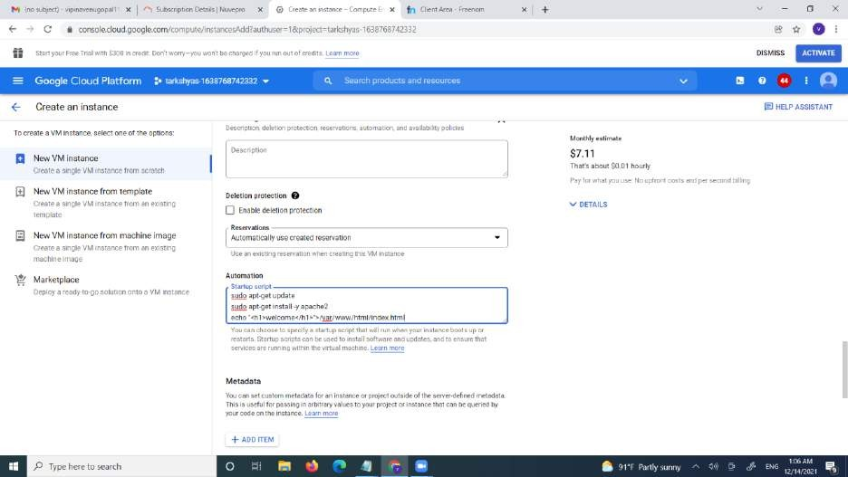



Click on create

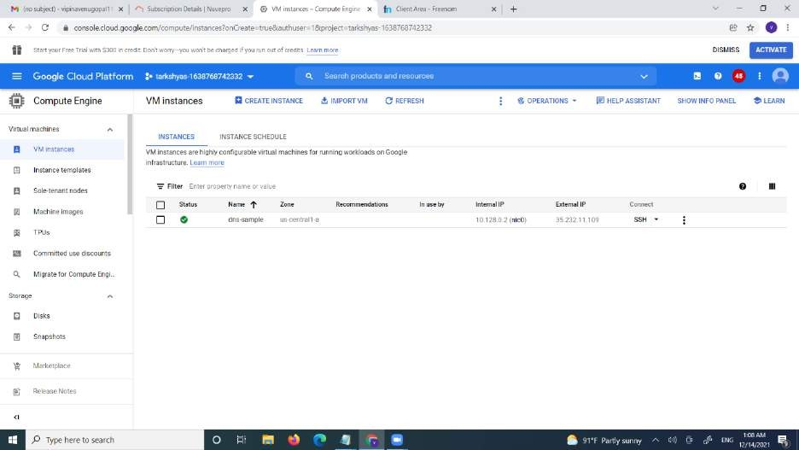

* vm instance is created
* Create a DNS zone

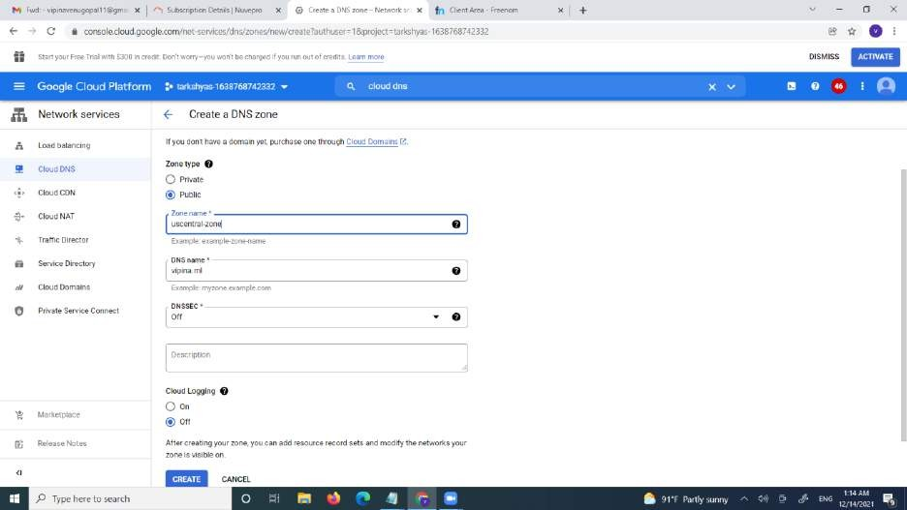

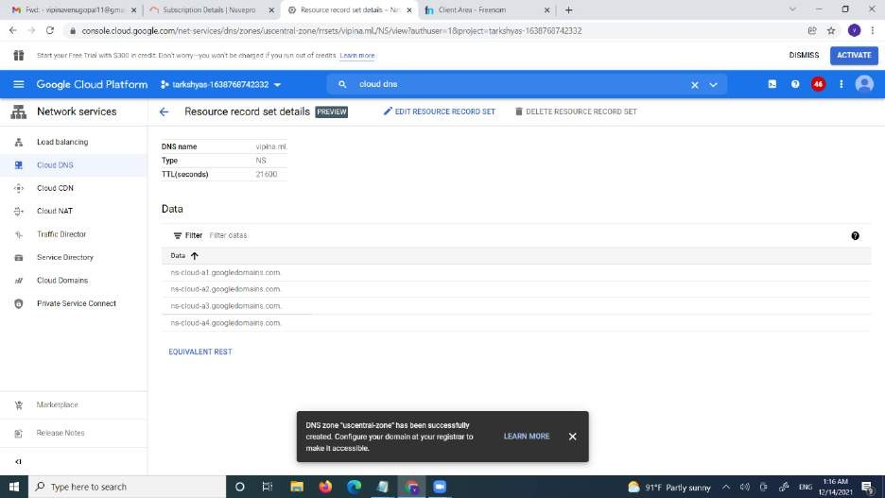

* This is my free domain

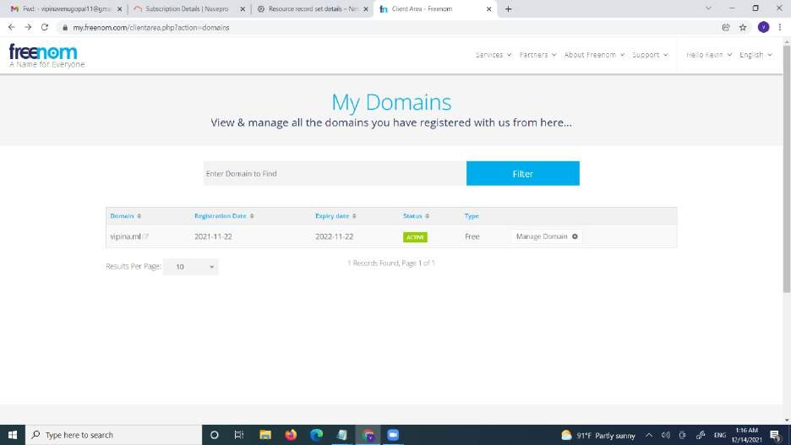



+ 0' ¥ rriy.Ireegomcom^c!iefrz+eophp7acdou do'no rdetaIIs&:Id : ^1Z2P 10 

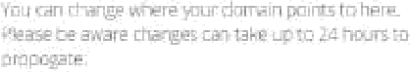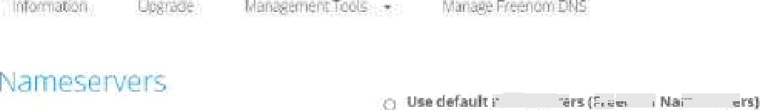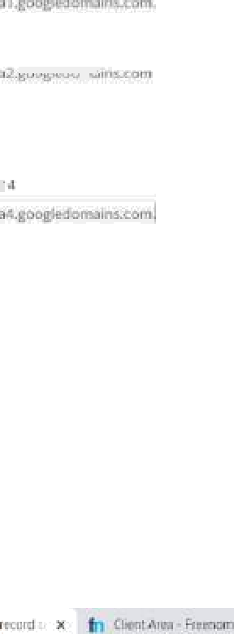

*P* in here to wr‹n

r. +

•



I- Greata record set

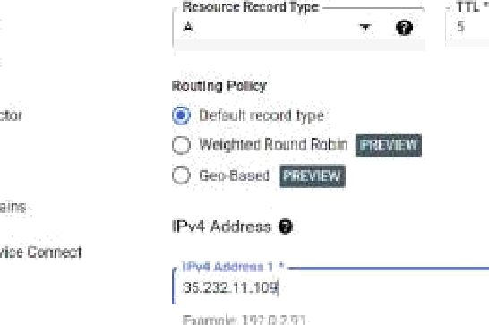

 

*P* in here to wr‹n



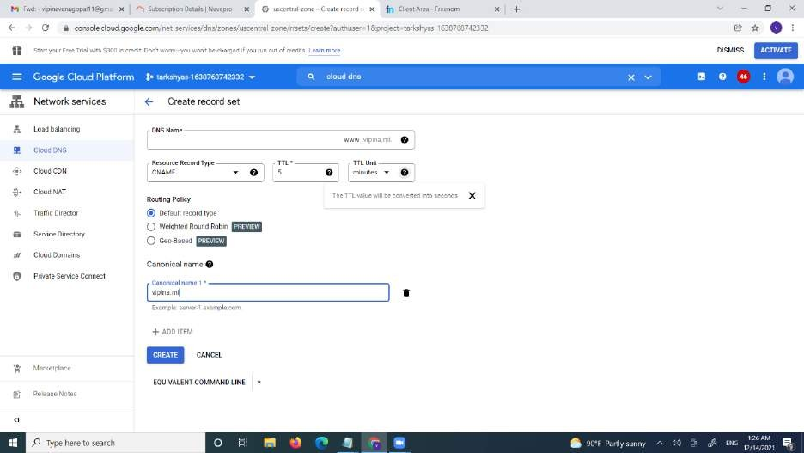

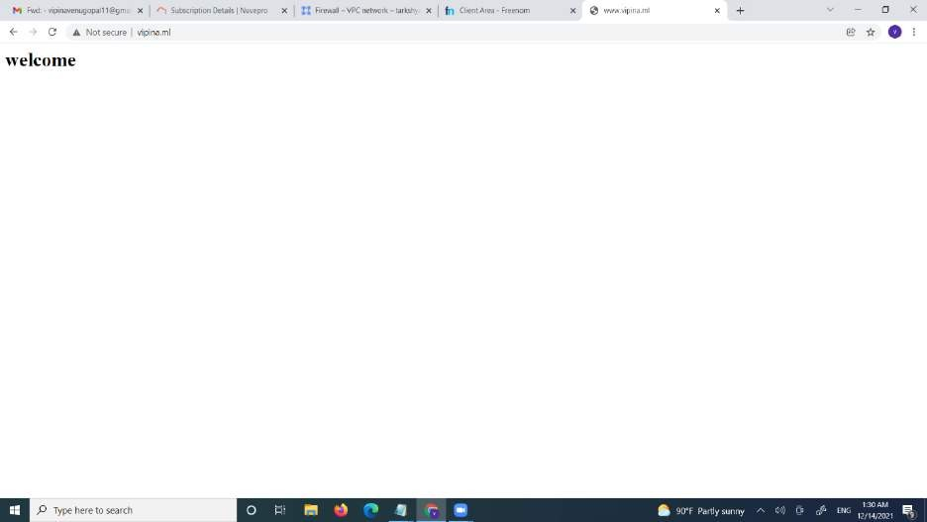

# Terraform

* First we want to create a service account with a role of project owner
* Then create the key and download json file

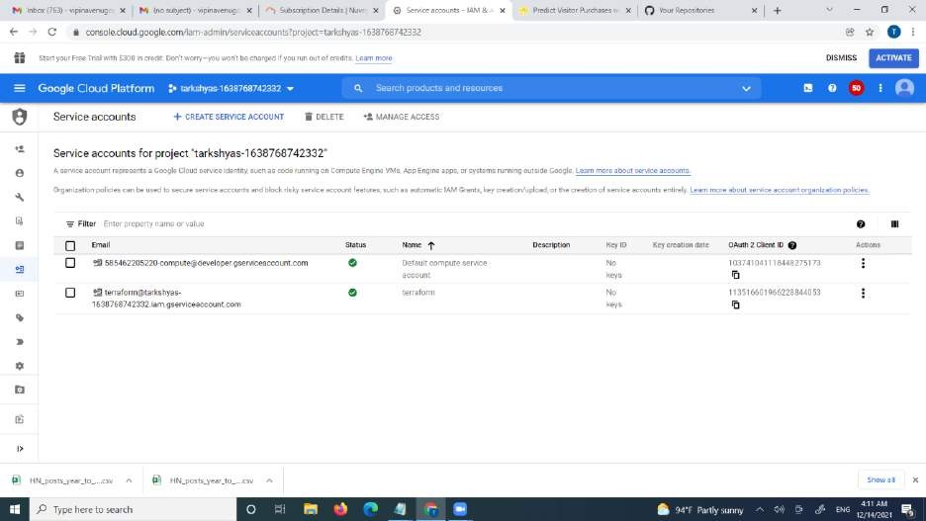

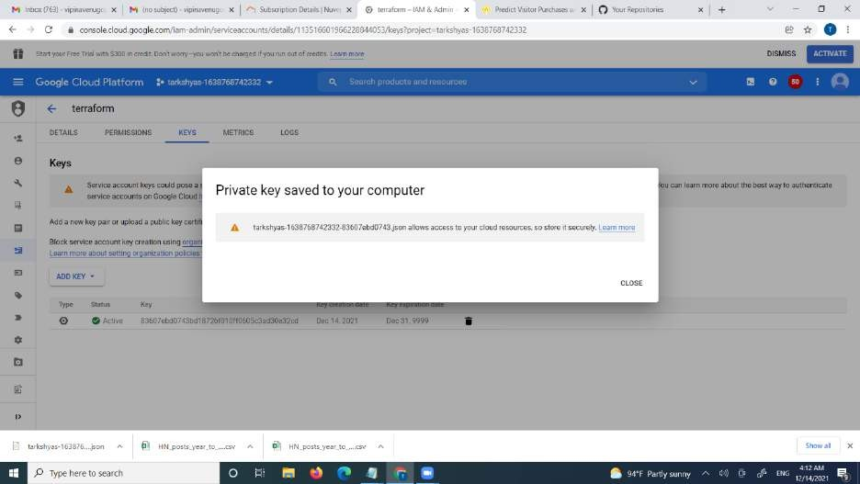

* Then install terraform 0.12.29 version

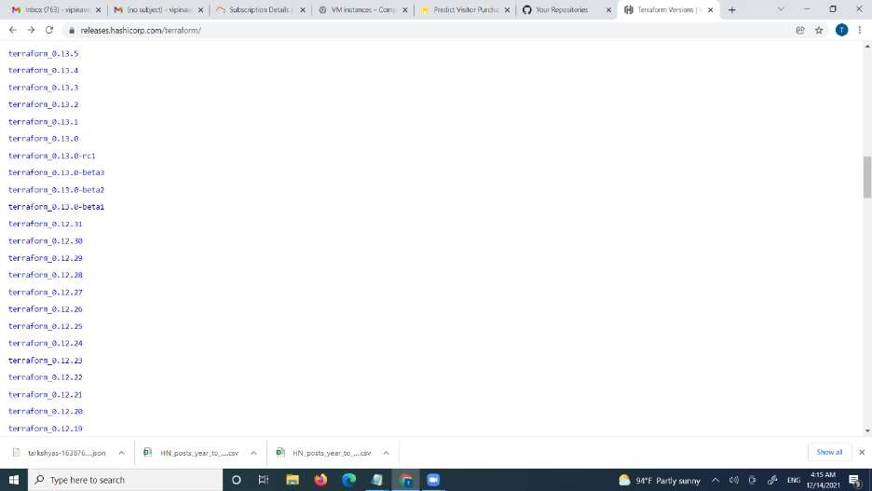

* Open the visual studio.
* Create a file vm.tf and provider.ft

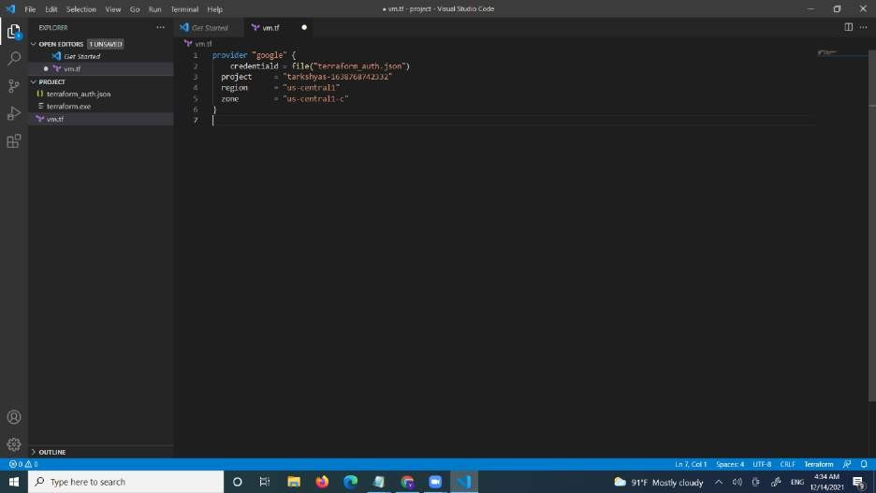

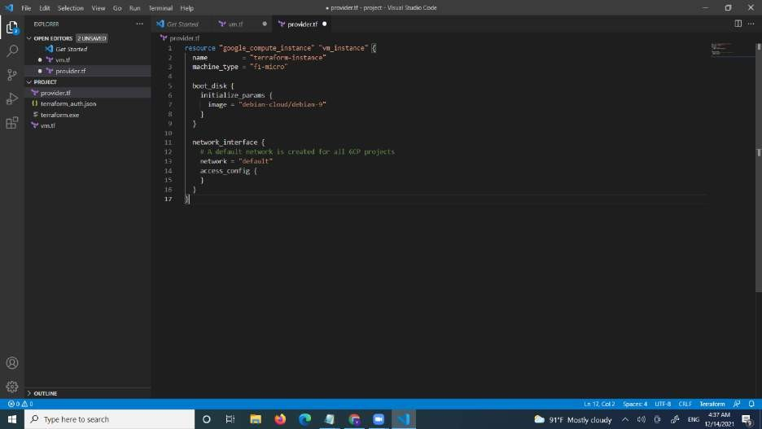

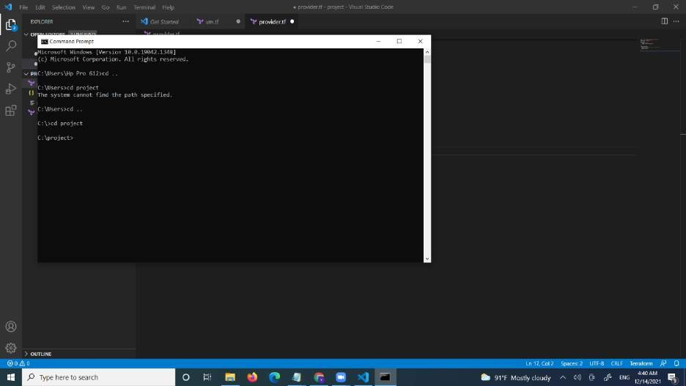

* gcloud init
* terraform init
* terraform plan
* terraform apply

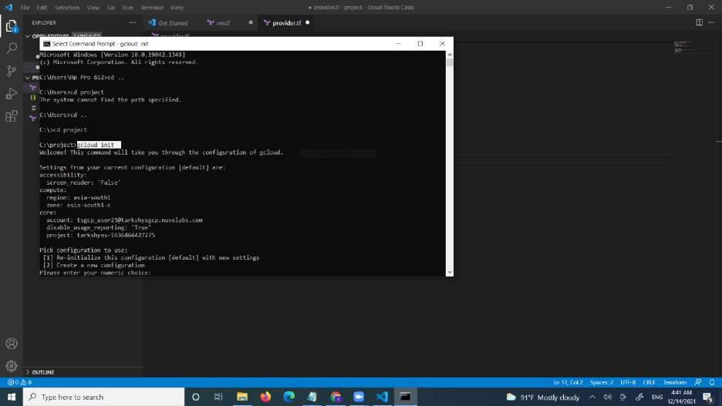

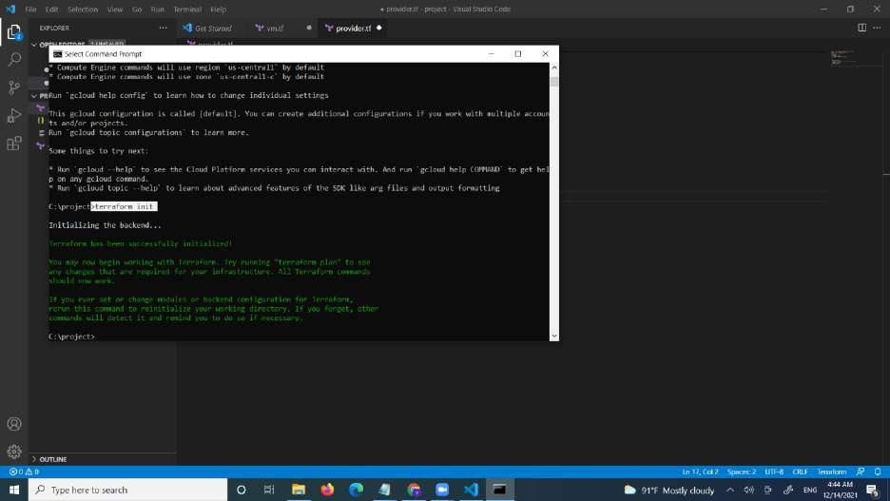

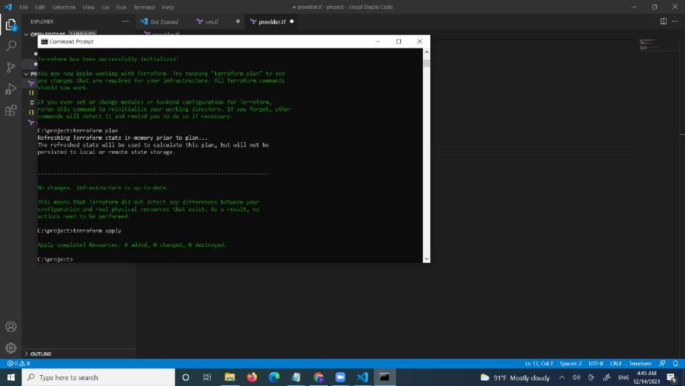

* we can see the vm is created

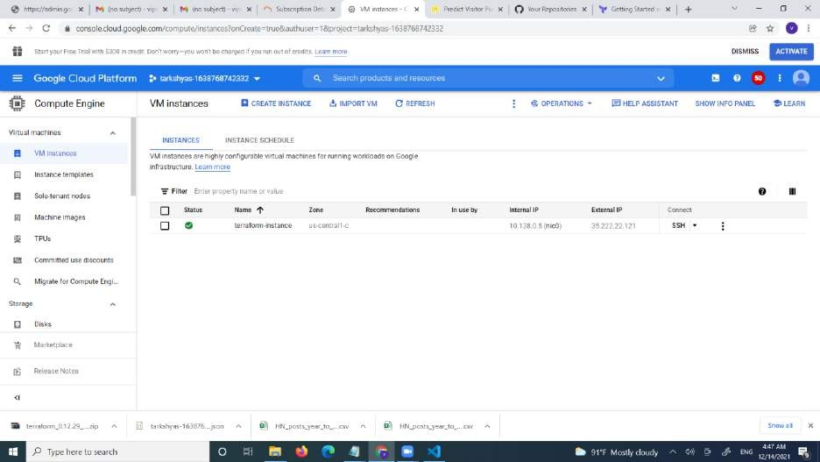

# Cloud Run

## installed the NodeJS dependencies so you can test the application before deploying:

* **git clone** [**https://github.com/googlecodelabs/monolith-to-microservices.git**](https://github.com/googlecodelabs/monolith-to-microservices.git)
* **cd ~/monolith-to-microservices**
* **./setup.sh**

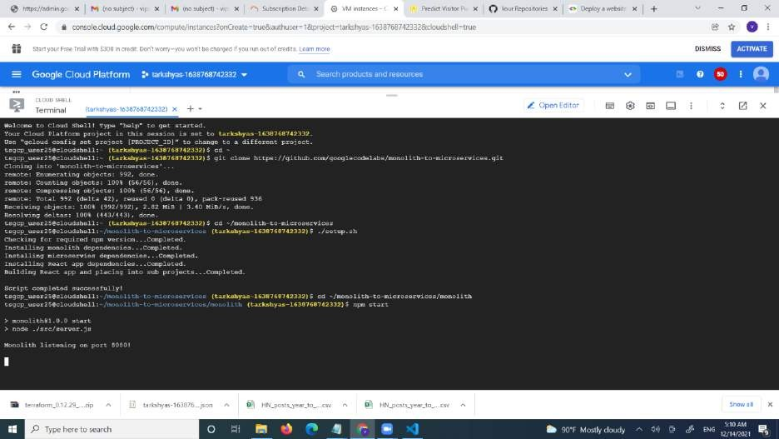

* Test application by running the following command to start the web server
* **cd ~/monolith-to-microservices/monolith**
* **npm start**
* Preview application by clicking the web preview icon and selecting **Preview on port 8080**.

## This should open a new window where you can see your Fancy Store web page in action.

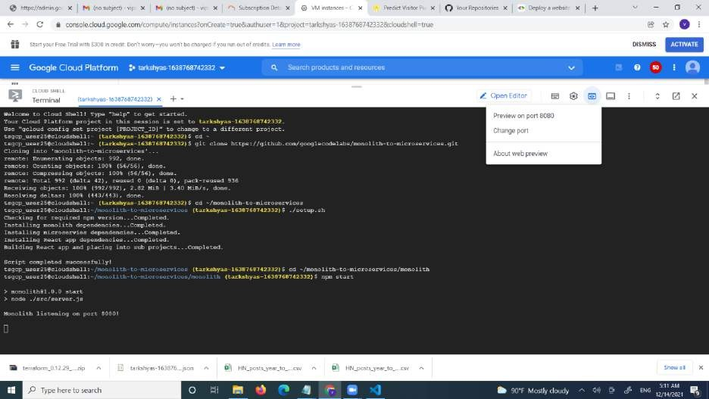

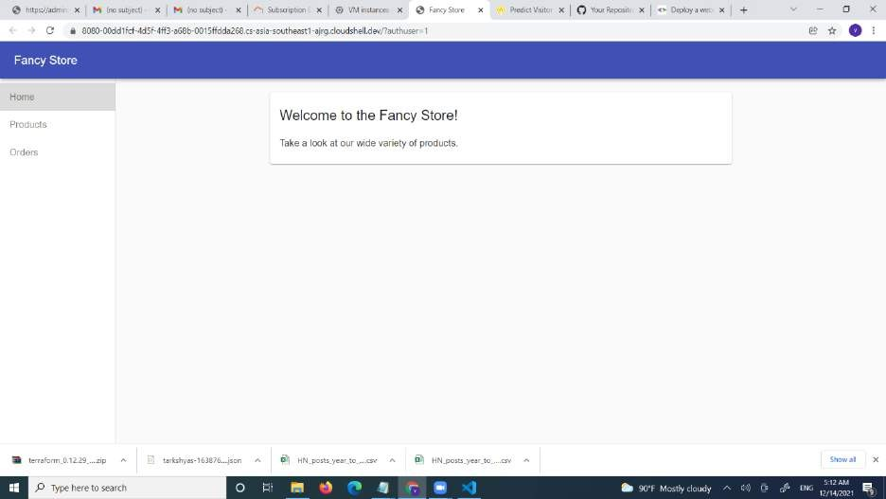

**VM instance**

* Deploy a docker container
* Then push the file to the container

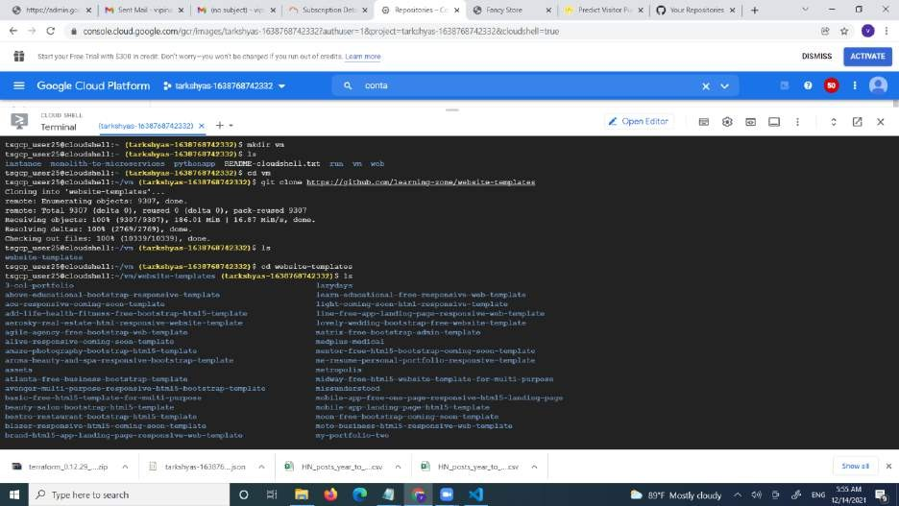

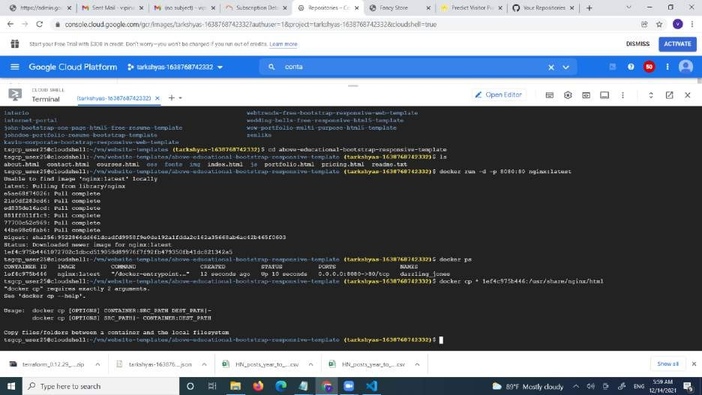

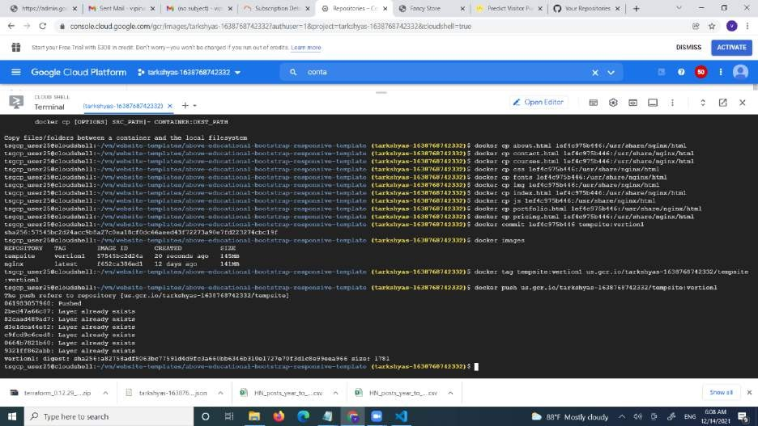

* We can see the container registory is created
* Click on the deploy GKE

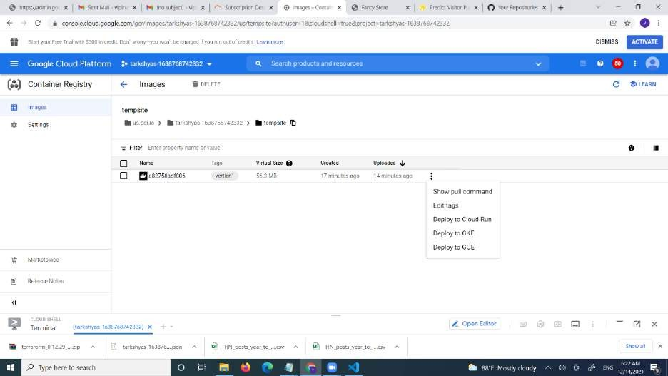

* Creating a vm instance

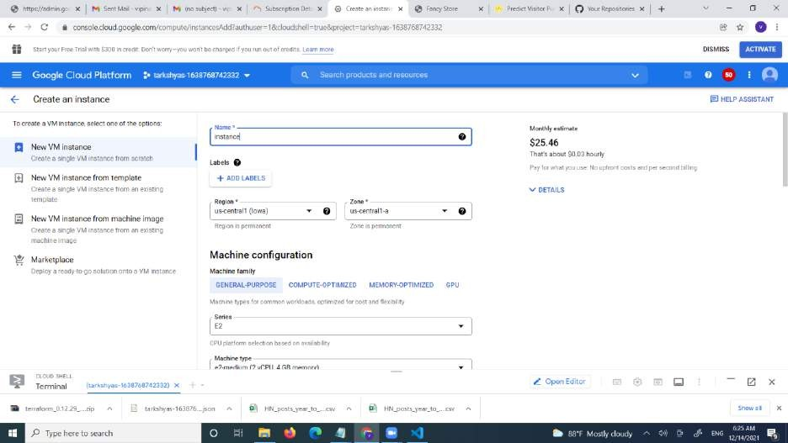

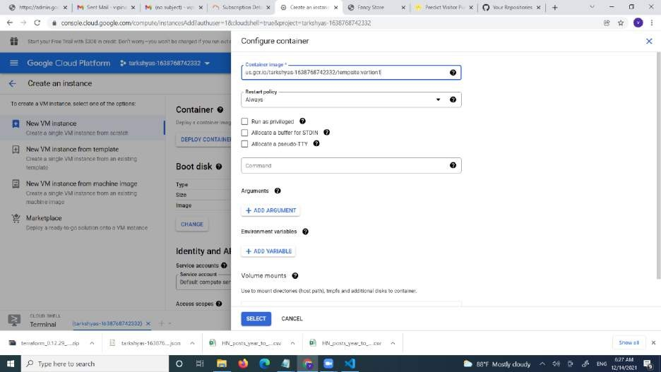

Click on container deploy.

Give the container image it is created using cloud shell

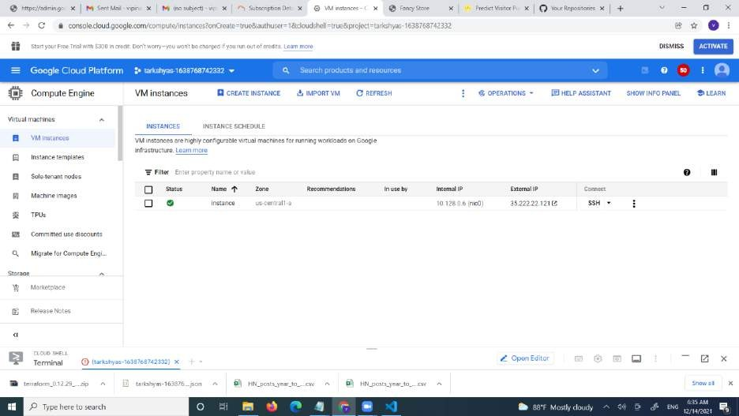

Then the vm is created

